**Latest News**

**Welcome to the second Orbitas, newsletter, for employees of this new company.** As you know formal consultations took place on 7th November, where staff were briefed on what they can expect from the potential transfer to the new company. Following on from this a question and answer sheet, approved by the Unions, has been produced and is available to everyone, if you would like a

a copy, just contact your line manager. We will carry on adding to this sheet whenever we are asked a question, in case there are others who are also wondering about the same things. The project team meets on a weekly basis and is busy driving things forward, the next stage is to obtain approval for the Business Case, from TEG (Technical Enablers Group), EMB (Executive Monitoring Board) and finally January 2014 Cabinet. Once the Business Case has been approved it means, if approval is given, that Orbitas will be able to trade legally as a Company, at the present time the Company is only registered.

**Stakeholder Groups**

Two meetings have now taken place between staff representatives, union officials, and members of the project team and the next meeting is scheduled for 19th December. These meetings are an opportunity for your representatives to raise issues, concerns, relay your ideas and suggestions on how we can work together to ensure that Orbitas is as successful as possible. Some of the suggestions/ideas from the last meeting were:

* Ensure that staff are kept fully informed of all developments – either through the notes from the stakeholder group meetings; this newsletter or by e mail to the representatives who would cascade the information down.
* New ideas for service delivery to be kept by Gareth on an Orbitas “Register of Ideas”
* Once the Executive Board is formally established to arrange meetings with staff.
* Contact details of staff representatives to be made available through this newsletter
* A brief paragraph on the Members of the Executive Board to enable staff to know a little bit more about them.
* Samples of Uniform/Protective Clothing to be made available to allow staff to make a more informed decision on colour(s)

I believe that these meetings are extremely beneficial to everyone concerned with the development of Orbitas and will play a major part in the shaping of the company as it evolves.

**Orbitas, Bereavement Services Limited**

**December 2013 – Issue 2**

[](http://www.google.co.uk/imgres?imgurl=http://www.cheshireeast.gov.uk/images/kevin%20melling01.jpg&imgrefurl=http://www.cheshireeast.gov.uk/council_and_democracy/council_information/media_hub/press_releases/previous_press_releases/press_releases_april_2013/management_revamp_at_council.aspx&usg=__V9TWMZUds_LOFkaW8ZfpC--pjCU=&h=180&w=130&sz=29&hl=en&start=1&sig2=2oCxSjPtia8CBoYK0ZTj9w&zoom=1&tbnid=SKc47houqZzC-M:&tbnh=101&tbnw=73&ei=ywVcUtXOC8iK0AWc7IDwCw&prev=/search?q=kevin+melling+cheshire+east+council&hl=en-GB&gbv=2&tbm=isch&itbs=1&sa=X&ved=0CCwQrQMwAA)



**Orbitas, Bereavement Services, Executive Board Members**

**Cllr David Marren, Chair –** Some of you may know my background but for those of you who don’t, I have been

Involved with Bereavement Services for over 30 years, both as an Executive Director with Crewe and Nantwich Borough Council and in my role as an Executive member of the Federation of Burial and Cremation Authorities, on which I am serving a second term. I am a Magistrate and have a Personnel background; I believe in treating people fairly and

decently as this goes to the heart of working relationships. I am also very keen on high service standards and Orbitas gives us the opportunity to raise the current high standards even further.

**Cllr Lesley Smetham, Vice Chair** - Lesley has been a Parish Councillor since 1999 and CEC Councillor, first for Macclesfield Forest and now for Gawsworth Ward. Lesley's paid working life was in administration with various companies and with Luton Borough Council and Macclesfield Borough Council. Lesley studied as a mature student with the Open University gaining an MA (Environment, Policy and Society) and BSc (Hons).  
  
**Cllr Penny Butterill, Director -** I am married to Doug Butterill, with one son Timothy and granddaughter Alexandra, and have lived in Nantwich since 1975.   As a Cheshire East Councillor I sit on the Southern Planning Committee, I am also a Nantwich Town Councillor and work with many community groups. I first became involved with Bereavement Services when I was Crewe and

Nantwich Council’s  Portfolio holder for the Local Environment over 10 years ago.  I have always found Bereavement staff to be dedicated and professional and look forward to working with you all as we move forward together.

**Useful Contacts: Staff Stakeholder representatives:** Sandra Daniels – 01270 685547; [Sandra.daniels@cheshireeast.gov.uk](mailto:Sandra.daniels@cheshireeast.gov.uk) Graham Bennett – Crewe Cemetery Office Dave Mulliner – Crewe Cemetery Office Robert Warhurst – 01625 383946; [robert.warhurst@cheshireeast.gov.uk](mailto:robert.warhurst@cheshireeast.gov.uk) Anthony Gosling – 01625 383944; [Anthony.gosling@cheshireeast.gov.uk](mailto:Anthony.gosling@cheshireeast.gov.uk) Suzanne Roberts – 01625 422330; [suzanne.roberts@cheshireeast.gov.uk](mailto:suzanne.roberts@cheshireeast.gov.uk) **Union Representatives: GMB** Shawn Reed – 07896346448; [shawn.reed@cheshireeast.gov.uk](mailto:shawn.reed@cheshireeast.gov.uk) Chris Millington – 07795697595 **Unison** Craig Nicholson – 01270 371188; [craig.nicholson@cheshireeast.gov.uk](mailto:craig.nicholson@cheshireeast.gov.uk) Tracey Evans – [tracey.evans@cheshireeast.gov.uk](mailto:tracey.evans@cheshireeast.gov.uk) **UNITE** Steve Otter – 07534535054 – [steve.otter@cheshireeast.gov.uk](mailto:steve.otter@cheshireeast.gov.uk) Paul Gibson - 07845222332

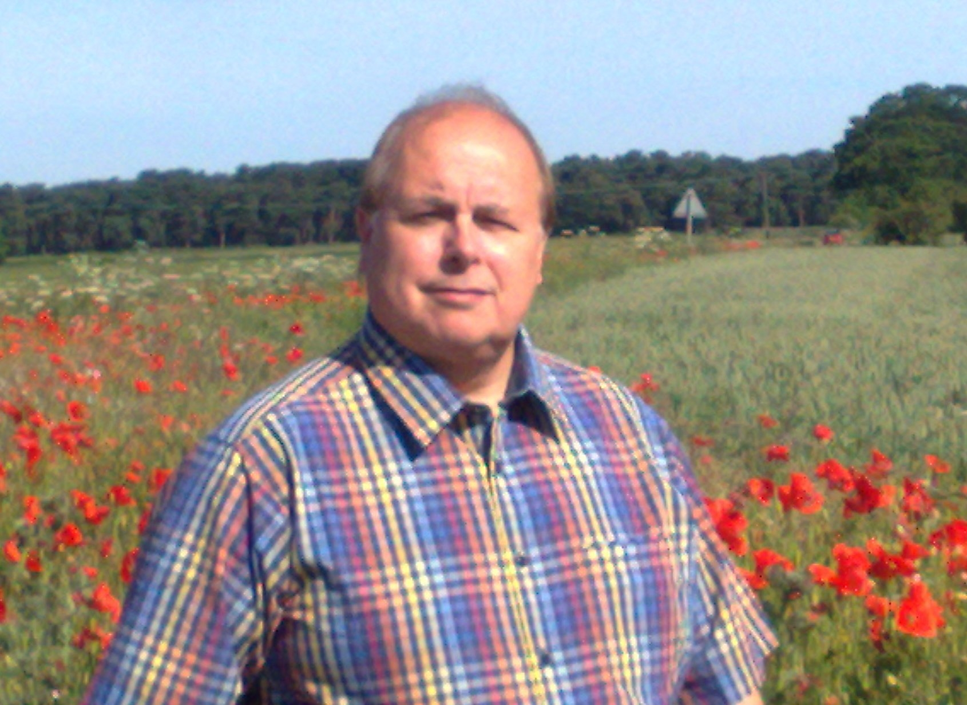

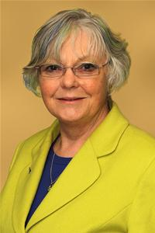

[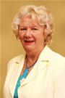](http://moderngov.cheshireeast.gov.uk/ecminutes/mgUserInfo.aspx?UID=1143)

