**Everybody Leisure News**

**January 2014 issue 7**

Happy New Year and welcome to 2014 and another edition of the staff newsletter which aims to provide you with the latest information on the progress being made to establish your new Leisure Trust. Since the last issue there has been plenty going on including –

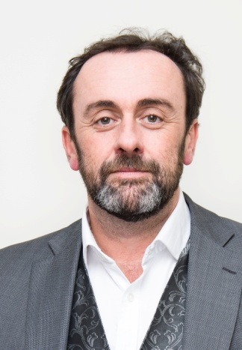**STOP PRESS!!**

It has now been confirmed that Peter Hartwell the current Head of Public Protection and Enforcement is to be the new Chief Executive Officer for the Trust. Peter has now been seconded to the new company when he will then transfer along with everyone else on the 1st April. His first duty as CEO will be to attend the Everybody Leisure Staff Consultation Stakeholder group on the 10th January and will also be meeting teams at the February consultation sessions. The Council will continue to be represented by Mark Wheelton.

Peter writes -

“Happy New Year to you all!

2014 promises to be an exciting time for leisure services and sports development as we create the new charitable trust ‘Everybody’ and see major new investment in our facilities, particularly the Crewe Lifestyle Centre but also in Congleton and Macclesfield.

A little over 2 years ago I became the Head of Service responsible for leisure. At its meeting in November 2013, I was asked by the Board to take on the role of Chief Executive for Everybody Sport and Recreation and I am delighted to accept their offer and to continue, with you, the adventure we have started.

There is still much to do to establish the new charity whilst we continue to deliver quality services day to day. We have made a great start and I have no doubt, with our combined experience, knowledge and commitment we will create a new organisation that will improve our services for local people.

We are seeking to blend the best of our public service ethos with the entrepreneurial spirit of a company and take full advantage of this once in a lifetime opportunity to develop a new way of working to benefit everybody. Providing a great customer experience has to be our over-riding goal if we are to build on our current success in driving up memberships and increasing participation.

Whilst this is an exciting time for us all, I am aware too that any change, however positive, brings with it a degree of anxiety and uncertainty for staff.

If we are to succeed, if we are to develop our people and improve our services we must communicate well. We have made good progress during this transition period with the Everybody Newsletters and staff stakeholder meetings. In addition, now that I am formally appointed, I do intend to get out and about to all our centres to meet you and keep everyone updated on progress as well as provide whatever re-assurance for the future is necessary.

I am looking forward to working closely with you over the next few months, whilst we set up the new charity and in the longer term as we demonstrate the social return on investment in leisure of improved health and community outcomes for local people.

Kind regards

Peter Hartwell”

**TUPE Consultation – update**

As set out in the last Newsletter, during January 2014, managers will be offering staff the opportunity to have a 1to 1 and/or a group consultation meeting; this will be the opportunity to ask any questions and confirm existing employment records, ahead of the transfer.

Also in January, Directors and management representatives the company will be meeting with the recognised trade unions to discuss their plans for the company.

We have now finalised the dates/times for the second phase of the consultation process, whereby directors and management representatives of the new company will meet with all staff and trade union representatives. All staff will be welcome to attend on any of these date(s), regardless of which site they work at:

* + 7pm on 4th February 2014 - Macclesfield Leisure Centre
  + 5pm on 5th February 2014 – Sandbach Leisure Centre
  + 9:30am on 6th February 2014 - Nantwich Pool (inc staff from The Barony)
  + 2pm on 11th February 2014 – Holmes Chapel Library (Leisure & Play Development Team)
  + 9.15am on 12th February 2014 – Shavington Leisure Centre
  + 2pm on 12th February 2014 – Wilmslow Leisure Centre
  + 4:30pm on 13th February 2014 - Holmes Chapel Leisure Centre (inc staff from Middlewich leisure Centre)
  + 10am on 18th February 2014 – Knutsford Leisure Centre
  + 1pm on 18th February 2014 – Victoria Community Centre
  + 1:30pm on 19th February 2014 – Congleton Leisure Centre
  + 1pm on 20th February 2014 – Poynton Leisure Centre
  + 6pm on 20th February 2014 – Crewe Pool
  + 10am on 26th February 2014 – Westfields (Business Support Team)
  + 6pm on 27th February 2014 – Alsager Leisure Centre

**Everybody Leisure Staff Consultation Stakeholder Group**

The stakeholder group met again on Friday13th December at Congleton Leisure Centre and the minutes are now available on the [Sharepoint](http://cemyteams2010.ourcheshire.cccusers.com/CELT/Shared%20Documents/Leisure%20Services%20current%20values.doc) site.

The next meeting of the group is scheduled for **Friday 10th January** at Alsager Leisure Centre where there will be a further session on trust values but also attended this time by a senior manager and a number of directors from the new company. This will be the first opportunity for staff to discuss this issue with the new Board and it will help the directors as they work towards finalising the vision at their next Board meeting later in the month.

**News From The Marketing & Business Support Team**

**Xn Project update -** The rollout of new leisure management system is now picking up pace with “Go Live” at a number of sites. A BIG THANKYOU to everyone who has and still is involved in making this complex project come to fruition. It will be worth it for both customers and staff!

**Leisure Centre News**

Mike harding reports “I attended the CE Best of the Best Awards Ceremony at Crewe Hall yesterday, an event to celebrate the Councils achievements and recognise some of its staff who have won ASPIRE awards over the past 12 months

There was an excellent representation from Leisure, with Middlewich, Knutsford and Sir William Stanier Leisure centres all having won gained monthly awards and as the Chief Executive announced everyone attending ‘we’re all winners!’

The event for leisure centres however, got even better as not only Rachel Blackham from Sir William Stannier won the Annual Award in the ASPIRE People category, but the staff at Middlewich LC won an Annual Team Award for Response.

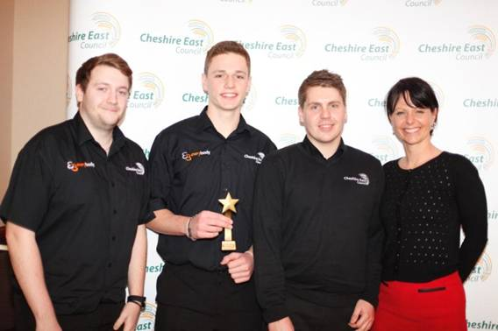

**Team Response** – From left to right, Danny Coyne, Andrew Zimmer and Ryan Barlow received the Team Response award from Caroline Simpson.

The citations read as follows:

**Rachel Blackham**. Rachel regularly supervises the roller disco at the centre with numbers regularly exceeding 90 teenagers. Rachel often has to deal with difficult situations but on this occasion she had to ban a group of girls who had been threatening and bullying other customers. Rachel was met with verbal abuse and treats but handled the situation in a very responsible and mature way, ensuring the safety and protection of other customers.

**The team at Middlewich LC** Following heavy snowfall in January the new Outdoor Synthetic Pitch could not be used. Although normal procedure would be cancel bookings, staff at the centre did not want to let their new customers down. They manually cleared the pitch over two days enabling 16 football sessions to take place, generating an income of over £700”.

**Well done to all!**

**Leisure Development News**

Some excellent news from Sport & Play Development Officer Natalie Mitchelmore, that the team’s award winning Street Sports programme overachieved its targets for Autumn with attendances for the evening sessions at over 2100. This is the highest attendances seen so far. Well done to all concerned!

**And Finally........**

[](http://static.movember.com/uploads/2013/profiles/cce/ccea4f1e2aca15d36c9fa6bee2ec4af9-528cdc637a4e5.jpg)A big thank you to all customers who kindly donated to the ‘Shavember’ team in their mission to change the face of men’s health. The chaps took part in a Movember fundraiser to raise money to help fight prostate and testicular cancer. We raised a grand total of £240.00 all of which was made possible by the generosity of our customers at Shavington Leisure Centre.

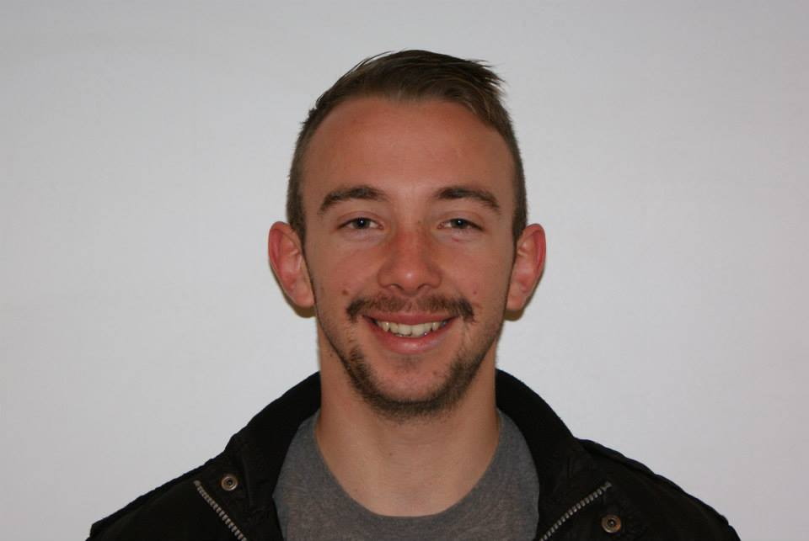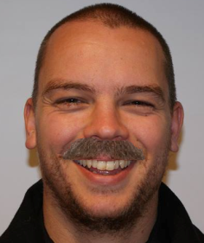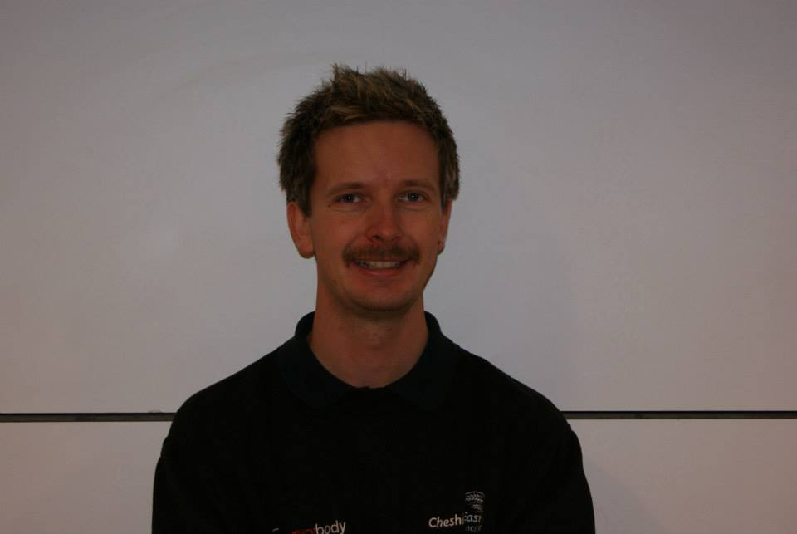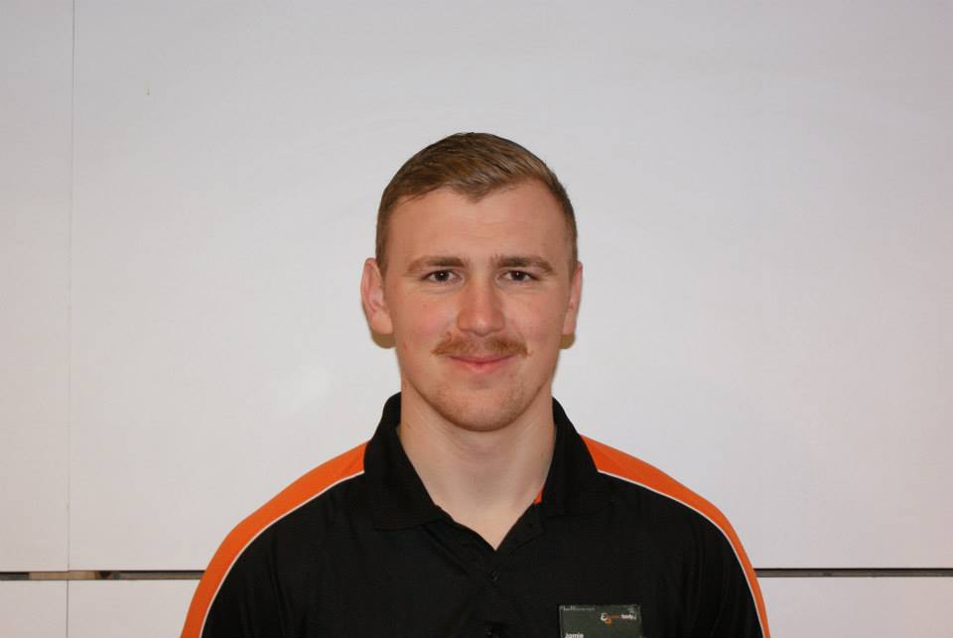

**Further information**

For further information on anything contained in this newsletter please contact:

Mark Wheelton – Leisure Services Manager

Tel: 01270 686679

e-mail: [mark.wheelton@cheshireeast.gov.uk](mailto:mark.wheelton@cheshireeast.gov.uk)