Everybody Leisure News
February 2014 issue 8

Welcome to another edition of the staff newsletter which aims to provide you with the latest information on the progress being made to establish your new Leisure Trust. Since the last issue there has been plenty going on including –

News From The Trust
Dear Everybody,
I mentioned in the last newsletter that there is much to do to establish our new charity. One month on and there is still a lot to do! Little by little, one piece at a time, decisions are being made, agreements put in place and new ways of working being developed with your help.
With the 1st April transfer date approaching, momentum is increasing and we have made great strides in setting out our strategic business planning framework and agreeing the values by which we will work. The Council too has drafted its contract requirements and the outcome specification that we will work to for the next few years.
I am grateful to everyone, not just those involved in the project, but also to those who keep the service going, day-to-day, professionally and without any fuss, so that we have the best possible start for the launch of ‘Everybody’ in April.
Without this continued commitment and effort, there wouldn’t be a business to transfer!
Our Values
Before Christmas, all centres and teams put forward their collective thoughts on what sort of provider organisation you want to work for and what sort of service we want to provide to our customers. This detailed work was then supplemented and reinforced by the staff stakeholder meeting on 10th January. On the 21st, the Board met to agree our organisation’s values, taking account of all that you have said.
These values, now developed by all of us, are the foundation of all we hope to become - individually, as a team and as a charitable business. They are the most important part of creating that fresh culture and distinct way of working for the future that we all hope for and that will benefit local people. This is in accordance with the vision of the Leader of the Council, Cllr Michael Jones, in establishing a number of new organisations to improve services for the people of Cheshire East and to give staff the freedoms and flexibilities to deliver more.
We have decided not to have a single, all-encompassing word with the values then developed to fit the acronym. Instead we have agreed a simple phrase for each value which we think captures what matters most to us all.
The proposed values are set out later in this edition and I welcome your thoughts on what we have produced prior to their inclusion in our final business and delivery plans.
Don’t forget our ‘Commissioner’ is Cheshire East Council so making sure we work and align to their strategic outcomes and values, and have a proper protocol over branding is essential. This will be worked in the next few weeks with colleagues.
Mission & Strategic Aims
In setting the strategic direction of ‘Everybody’, we have sought to take account of all the various influences and expectations on us and on our services. These include our own charitable purposes, the Council’s contract specification, customer needs and, of course, our ambitions for the future.
Our mission statement, our over-riding purpose is to provide ‘Leisure for Life’. It is felt that this captures not only our drive to improve people’s health and quality of life but also that we seek to make active recreation a habit for a lifetime too – from the earliest years to later days. Both aspects of our work captured in a single, simple phrase.
The five strategic aims cover business growth, developing our people, customer service, working with communities and partners and crucially, seeking to change lives through the power of, and participation in, sport and recreation.
The mission statement and strategic aims are also included in this newsletter and again, I would encourage you to send through your comments (for good and bad!) on our proposals.
Charitable status
Our application to the Charities Commission has been made with the help of our legal advisors and I will update you on this vital milestone as soon as I can. Fingers crossed, our work to date and our vision for the future will secure our registration quickly and without any further hurdles to jump over!
Finally, I am looking forward to meeting you all during February at our planned consultation events to discuss our proposals for the medium term and to update you on progress and the next steps of the project and transfer process.
Importantly too, I want to listen to your ideas and ambitions, to your hopes and fears for the future, as we move ever closer to Everybody Sport & Recreation.
Kind regards
Peter
TUPE Consultation – update
As set out in the last Newsletter by now I am hoping that you should have had a 1to 1 and/or a group consultation meeting with your manager to ask any questions you may have and confirm existing employment records, ahead of the transfer.
The second phase of the consultation process, whereby directors and management representatives of the new company will meet with all staff and trade union representatives will shortly commence. All staff are reminded that they will be welcome to attend on any of these date(s), regardless of which site they work at:
  - 7pm on 4th February 2014 - Macclesfield Leisure Centre
  - 5pm on 5th February 2014 – Sandbach Leisure Centre
  - 9:30am on 6th February 2014 - Nantwich Pool (inc staff from The Barony)
  - 2pm on 11th February 2014 – Holmes Chapel Library (Leisure & Play Development Team)
  - 9.15am on 12th February 2014 – Shavington Leisure Centre
  - 2pm on 12th February 2014 – Wilmslow Leisure Centre
  - 4:30pm on 13th February 2014 - Holmes Chapel Leisure Centre (inc staff from Middlewich leisure Centre)
  - 10am on 18th February 2014 – Knutsford Leisure Centre
  - 1pm on 18th February 2014 – Victoria Community Centre
  - 1:30pm on 19th February 2014 – Congleton Leisure Centre
  - 1pm on 20th February 2014 – Poynton Leisure Centre
  - 6pm on 20th February 2014 – Crewe Pool
  - 10am on 26th February 2014 – Westfields (Business Support Team)
  - 6pm on 27th February 2014 – Alsager Leisure Centre
Everyone is reminded that both existing employees and casual workers are encouraged to attend any of the above. Remember to bring along your questions and ideas!

Everybody Leisure Staff Consultation Stakeholder Group
The stakeholder group met again on both the 10th and 24th January and the minutes are now available on the Sharepoint site. These were excellent sessions where the new CEO of the Trust Peter Hartwell and two Board Directors include the chairman attended to discuss staff views on the new trusts values and vision. The resultant draft values as discussed in the new CEO’s article are set out below.
As consultations will be taking place throughout February the next Consultation Stakeholder Group meeting will be Friday 28th February 10am – 12 noon at Crewe Pool, followed by one on Friday 14th March 1.00pm – 3.00pm at Poynton Leisure Centre.

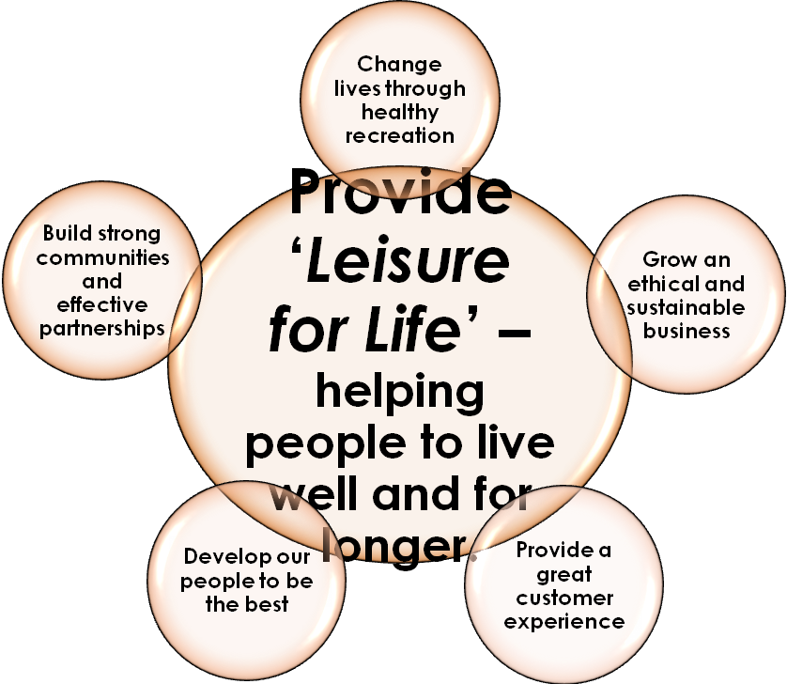

News From The Marketing & Business Support Team
Xn Project update - A BIG THANKYOU to everyone who has and still is involved in making this complex project come to fruition. Whilst there continue to be challenges it will be worth it for both customers and staff!
Leisure Development News
STOP PRESS – Exciting news, the Queen’s Baton Relay will be visiting Cheshire East on 31st May as part of its national tour ahead of the Commonwealth Games. More details in the next newsletter.
Further information
For further information on anything contained in this newsletter please contact:
Mark Wheelton – Leisure Services Manager Tel: 01270 686679
e-mail: mark.wheelton@cheshireeast.gov.uk

