To: Secretaries of Local Government branches with members in education, Education Convenors (England)

Wales, Northern Ireland and Scotland for information only

b.thomas@unison.co.uk

ED/02/15

22 January 2015
Dear Colleague
Childcare Disqualification Regulations – Early Years Staff
Further to circular ED11/14 some additional guidance in relation to application of the Childcare Disqualification Regulations is attached.

Scope of the Regulations

In response to a legal challenge from trade unions, the DfE has clarified the scope of the regulations. It now confirms that for schools, during school hours, the regulations only apply to staff routinely working with children aged five and under. Staff who only work with children aged 6-8 during school hours are not subject to the regulations. This is because activity for pupils of compulsory school age during school hours is specifically excluded from the childcare regulations by section 18(3) of the 2006 Education Act.

However, the regulations do apply to staff who work in out of hours provision, i.e breakfast and afterschool clubs, who work with children up to the age of eight.

The supplementary advice issued by the DfE did not make it clear that staff working with pupils aged 6-8 during school hours are not covered by the regulations. As a result of this, many schools and local authorities have sought declarations from this group of staff.

It has been reported by Ofsted that around a third of the waiver applications received to date have been in cases where there was no need for the member to apply for a waiver because either they were not part of the workforce covered by the regulations or the offence declared was not relevant to the Childcare Disqualification Regulations.

UNISON believes that; all schools and local authorities will need to revise the scope of the staff they are seeking declarations from, that any staff who are suspended should be allowed to return to work and any information collected in respect of this group of staff should be destroyed.

Access to medical records

Some schools appear to have included in their disclosure forms requests for information about the medical records of staff. There is nothing in the Childcare Disqualification Regulations that requires schools to obtain medical information.

The Information Commissioner gives clear guidelines to employers about seeking medical records of staff. Medical records are considered sensitive data and employers are required to meet a sensitive data condition before they can seek this information.

Unless there are specific health issues relating to an individual concerning their capability to undertake their job, this condition is unlikely to be met.

UNISON believes that routine collection of medical records of all staff is not compliant with the Data Protection Act and that schools should not be seeking to collect this data. If schools are insisting on seeking to collect this data, complaints to the Information Commissioner should be considered.

Ofsted waiver application processing and criteria

Before making a decision on a waiver application, Ofsted say they will consider the following:

- the risk to children;

- the nature and severity of any offences, cautions or orders disclosed;

- the age of any offences or orders;

- repetition of any offences or orders or any particular pattern of offending;

- notes of any interviews with the disqualified person;

- any other information available from other authorities, such as the police; and

- any mitigating factors.

If you have been disqualified “by association”, it is UNISON’s view that your character should also be taken into consideration. The person best placed to provide Ofsted with relevant information is likely to be your head teacher or manager. You may want to request a character reference from them and attach it to your waiver application.

At the moment we have no information from Ofsted concerning the amount of time taken to process waiver applications. However, we understand that there is a backlog of cases and that there are some delays processing waiver applications.

The DfE have arranged a meeting with trade unions and other stakeholders concerning the application of these regulations. We will be making clear our opposition to the regulations and their unfair impact on support staff. The DfE have indicated that there will be a further consultation on the guidance in the spring. However, there is no indication that the legislation will be withdrawn.

If you have any further questions about the application of these regulations, please contact, b.thomas@unison.co.uk .

Yours sincerely
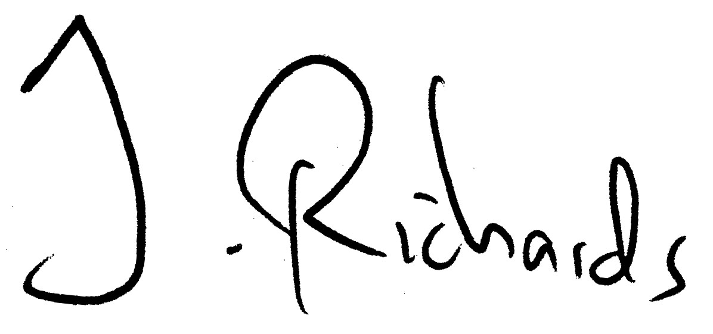
National Secretary
Education and Children’s Services

