To: Secretaries of Local Government branches with members in education, Education Convenors (England)

Wales, Northern Ireland and Scotland for information only

b.thomas@unison.co.uk

ED/11/14

15 December 2014
Dear Colleague
Childcare Disqualification Regulations – Early Years Staff
The Department for Education (DfE) has recently published supplementary guidance to ‘Keeping Children Safe in Education’ updating legal requirements on schools and nurseries concerning the disqualification of people from working with children aged eight or under. These regulations only apply in England.

https://www.gov.uk/government/uploads/system/uploads/attachment_data/file/362919/Keeping_children_safe_in_education_childcare_disqualification_requirements_-_supplementary_advice.pdf

It appears that the government has now interpreted the Childcare Disqualification Regulations 2009 as being applicable to schools and staff working with children aged eight or under are now likely to be asked for further disclosures concerning not just themselves, but also the people that they live with.

Disqualification by Association

The guidance highlights the separate and additional requirements on schools and nurseries placed on them by the Childcare Act 2006 and the Childcare (Disqualification) Regulations 2009. These include ‘Disqualification by Association’. This means that staff can be barred from working in a school or nursery if someone who they live with or who works in their household is disqualified from working with children.

The guidance advises schools that they should be asking staff about whether they or anyone who they are living with is disqualified from working with children. If someone is living with someone who is disqualified from working with children; they too can be disqualified by association.

Staff who are disqualified by association are able to make representations to Ofsted to seek a waiver to allow them to continue to work with young children.

Ofsted have published guidance on applying to waive disqualification. This can be found here:

http://www.ofsted.gov.uk/sites/default/files/documents/registration-forms-and-guides/a/Applying%20to%20waive%20disqualification%20early%20years%20and%20childcare%20providers%20from%20September%202014.pdf

Staff who are applying for a waiver are not allowed to work with children aged eight or under while their application is being considered.

It is an offence for a school or nursery to knowingly employ a member of staff barred from working with young children, including anyone disqualified by association.

This advice has only just been sent to schools and it is likely that many schools and nurseries will begin asking staff further questions about convictions and seeking declarations from staff that they are not disqualified, including questions about people that they live with and any convictions that they have. It appears that Ofsted are beginning to inspect school safeguarding procedures to ensure that schools and nurseries are complying with these regulations. The guidance also states that schools and nurseries may ask staff to sign a written declaration concerning the people they live with although this is not a requirement.

The DfE view is that these regulations will help protect children from staff who may be influenced by someone who has been deemed as unsuitable to work with children.

UNISON advice

UNISON is seeking further legal advice on whether these arrangements are appropriate for schools and as to whether they meet the requirements of the human rights and data protection acts. Whilst we regard the safety of children as paramount, we believe these new requirements are a disproportionate response and will do little to enhance safeguarding practice.

However, because these are statutory requirements it is highly likely they will be enforced by schools and local authorities and staff will be required to comply with requests for information until further advice is received.

If branches require additional legal support for members who require representation at tribunal, they should contact education@unison.co.uk

A FAQ is attached with further information for school staff and branches. If you have any further questions about the application of these regulations, please contact, b.thomas@unison.co.uk .

Yours sincerely
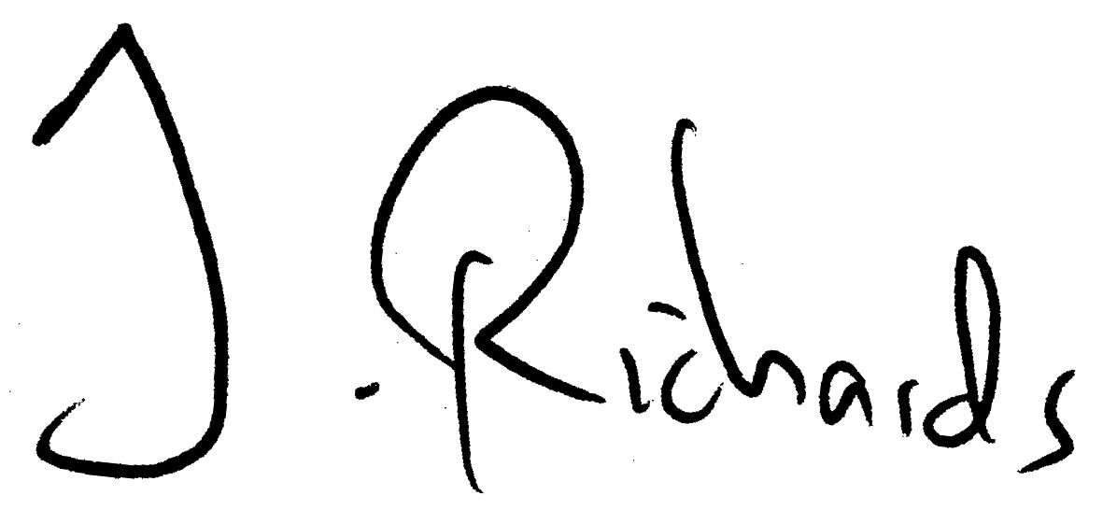
National Secretary
Education and Children’s Services
Childcare Disqualification Regulations- FAQ for UNISON members and branches.

Which staff are covered by these regulations?

It will only cover staff in nursery, infant or primary schools who ‘work in the relevant provision’, i.e. those who work directly with children aged eight or under and are in a position of trust. This will in include staff working in breakfast clubs or after school provision. If contact with young children is indirect or infrequent it is for the school to determine whether the member of staff is covered by the regulations.

Volunteers are not covered by statute, but it is likely that many schools will seek the same declarations from volunteers.

If staff are employed by contractors or an agency, it is their employers responsibility to ensure that these staff are suitable to work with children.

What are the reasons for disqualification?

Some people are automatically disqualified from working with young children if they have been barred from working with all children or been convicted of certain offences.

You could be disqualified if you, or someone you live with have been:

- Disqualified from working with children;
- Convicted or charged with an offence against a child;
- Convicted or charged with certain offences against an adult (for example, murder, kidnapping, rape, indecent assault);
- Listed on the Protection of Children Act 1999 (PoCA) list of persons considered unsuitable to work with children;
- Made the subject of a direction made under section 142 of the Education Act 2002, known as List 99, that you are considered not a fit and proper person to work with children;
- Made the subject of a disqualifying order;
- Made the subject of an order where a child has been removed from your care or prevented from living with you;

What information am I required to provide?

You are required to inform the school if you know that you or someone in your household has been disqualified from working with children or convicted of one of the listed offences.

You are not required to disclose minor convictions of someone in your household if they are not relevant offences.

What constitutes a household?

A household includes anyone who lives in the same house as you or who works in the house in which you live. This includes all family members and anyone who you might live within the same multi-occupancy house.

What if I don’t know the people in my household or don’t know if they have committed any offences?

Staff are required to give the information ‘to the best of their knowledge’. They are not expected and cannot be required to seek out this information from people they live with. Neither is it the responsibility of the school to seek out this information. If you do not know if someone has committed any offences this should not disqualify you from working with children.

What if I am unsure if the offence is covered by the regulations?

A full list of the offences that are required to be reported can be found in tables four and five of the attached briefing by Ofsted:

http://www.ofsted.gov.uk/sites/default/files/documents/other-forms-and-guides/c/compliance-investigation-and-enforcement-handbook/eycc/5%201a%20Disqualification.doc

If you are still unsure if the conviction is covered, it would be appropriate to report the conviction to the school and they can check with Ofsted if it is a relevant offence.

Can the school ask for a DBS (formerly CRB) certificate for someone else?

No. Schools can only ask for DBS certificates for staff and volunteers who work for the school. They have not been asked to seek DBS certificates and are not permitted to seek certificates from anyone else.

What happens if I make a disclosure that means I am disqualified by association?

The regulations state that schools cannot employ anyone who is disqualified by association to work with young children. Staff who are ‘disqualified by association’ are likely to be suspended from work. However staff can apply for a waiver from Ofsted to allow them to continue to work in the school. It is the responsibility of the member of staff who is disqualified to seek a waiver, rather than the schools’.

If staff are disqualified by association and required to apply for a waiver, they are advised to contact their union rep immediately.

It may be possible for schools to redeploy staff to work with older children while a decision on the waiver application is awaited.

Is it true that I may be disqualified if my child or children have ever been taken into care?

Yes, it is true that you may be disqualified from providing childcare if your child or children have ever been taken into care or been the subject of a child protection order. Schedule 1 of the Childcare Disqualification Regulations contains a list of orders relating to care and fostering which may prohibit you from providing childcare within the meaning of the Childcare Act.

How do I apply for a waiver?

You should email Ofsted (disqualification@ofsted.gov.uk) to request a waiver application and submit it to Ofsted at the earliest opportunity.

Details of the waiver application process and the information that you will be required to supply can be found here;

http://www.ofsted.gov.uk/sites/default/files/documents/registration-forms-and-guides/a/Applying%20to%20waive%20disqualification%20early%20years%20and%20childcare%20providers%20from%20September%202014.pdf

Members should seek advice from their branch before submitting their application. Ofsted will then make an assessment if you are likely to pose a risk to children and permit a waiver if appropriate.

It is not clear at the moment how long it will take for Ofsted to grant waivers. They may judge many cases to be straightforward and these cases could be processed quickly. In more complex cases they may seek interviews with applicants and these cases will inevitably take longer.

What will Ofsted consider in my waiver application?

Before making a decision, Ofsted say they will consider the following:

- the risk to children;

- the nature and severity of any offences, cautions or orders disclosed;

- the age of any offences or orders;

- repetition of any offences or orders or any particular pattern of offending;

- notes of any interviews with the disqualified person;

- any other information available from other authorities, such as the police; and

- any mitigating factors.

If you have been disqualified “by association”, it is UNISON’s view that your character should also be taken into consideration. The person best placed to provide Ofsted with relevant information is your head teacher or manager. You may want to request a character reference from them and attach it to your waiver application.

Will I be paid while I apply for a disqualification waiver?

UNISON believes staff should be redeployed or treated as though they are suspended on full pay whilst they await a decision on their waiver application.

What happens if I am not given a waiver?

If you are refused a waiver you are able to appeal to a Tier 1 Health and Social Care Tribunal. Branches should treat this like any other tribunal and may wish to seek further legal advice.

If you are not granted a waiver on appeal, it is possible that you will be dismissed as it will no longer legal for the school to employ you in your current role.

Is this process compliant with the data protection act?

The view of the DfE is that because these are statutory duties, it is legal for the school to collect information about third parties. We are reviewing this advice. However, any data collected must be treated as highly sensitive data and must be stored safely and remain confidential. Any breach of confidentiality should be treated very seriously.

