EMPLOYEE SELF SERVE – GUIDANCE FOR USE

CONTENTS

- Introduction
- How to access Employee Self Service
- Personal Information
- Payslip information
- Bank Details
- My Information
- Emergency Contacts
- Logging out
- Who to contact for help and assistance.

1. INTRODUCTION:

These guidelines have been developed in order to assist you with accessing and updating your personal information on line through Employee Self Service. If you follow the examples below, you will quickly be able to access your current and previous payslip information and employment history, from the beginning of Cheshire East, including assignments and ill health absences. You will also be able to update your bank details and your home address.

The examples given below can be enlarged by using the “zoom” facility on your toolbar. We refer in these guidelines to assignments – this is just another term for your job or jobs.

2. HOW TO ACCESS EMPLOYEE SELF SERVICE

1. Open the CE intranet 2. Select Tools and Applications

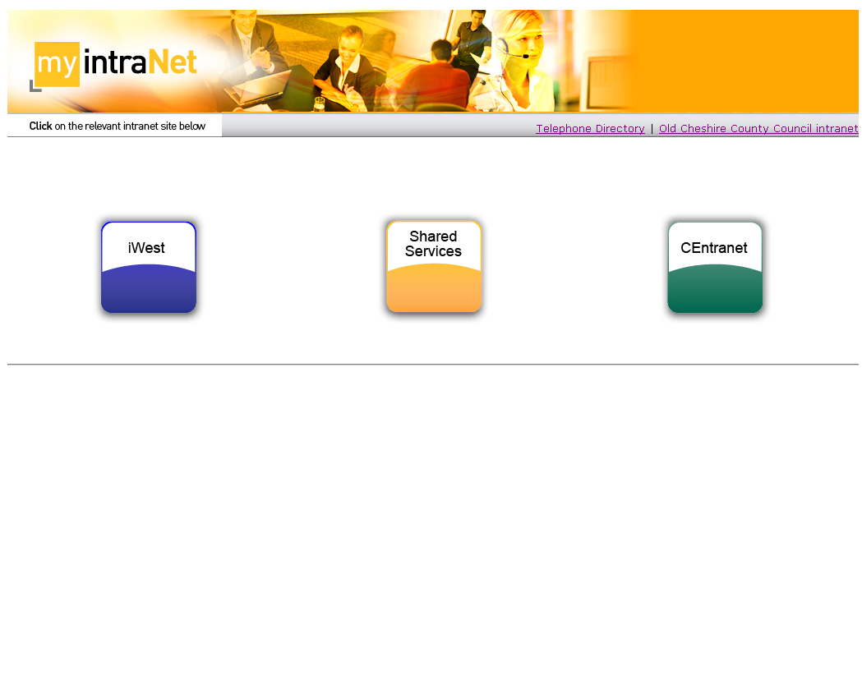
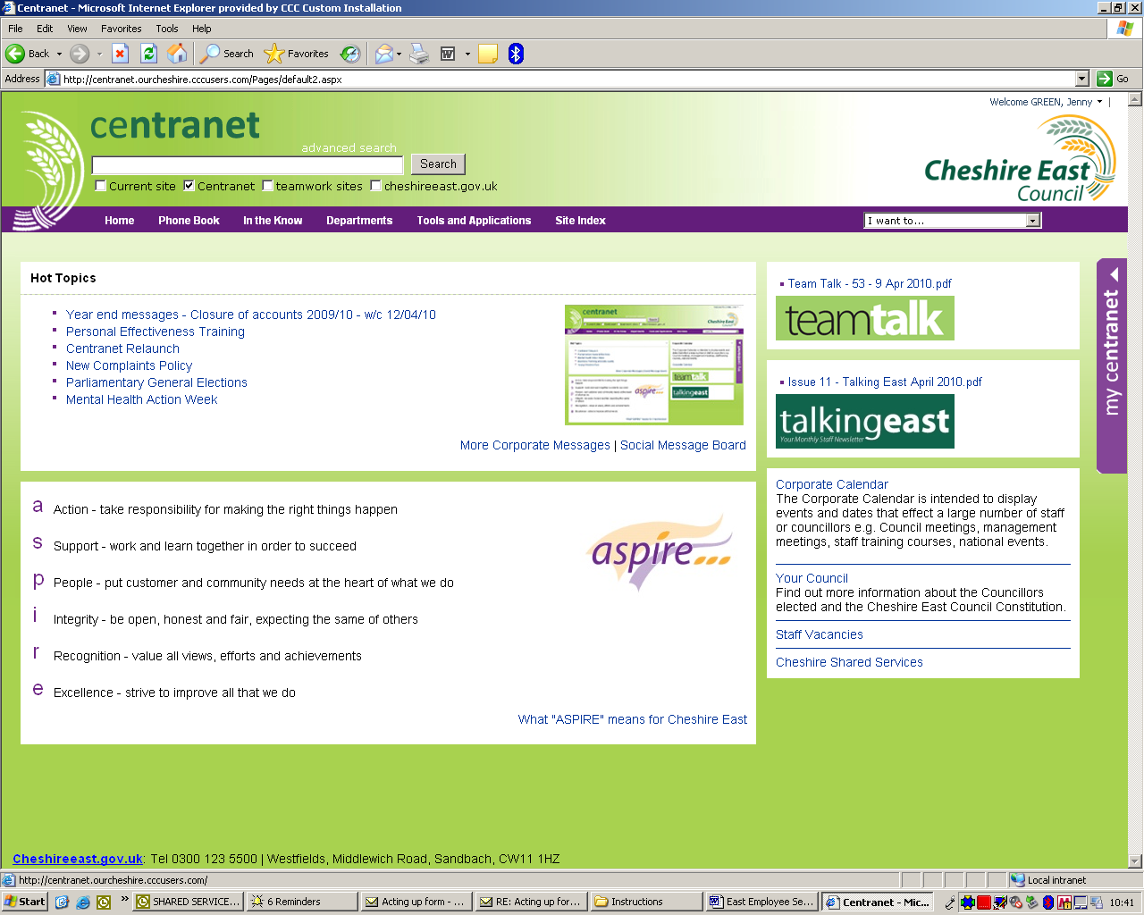
3. Select IBS login 4. Enter your Username and Password

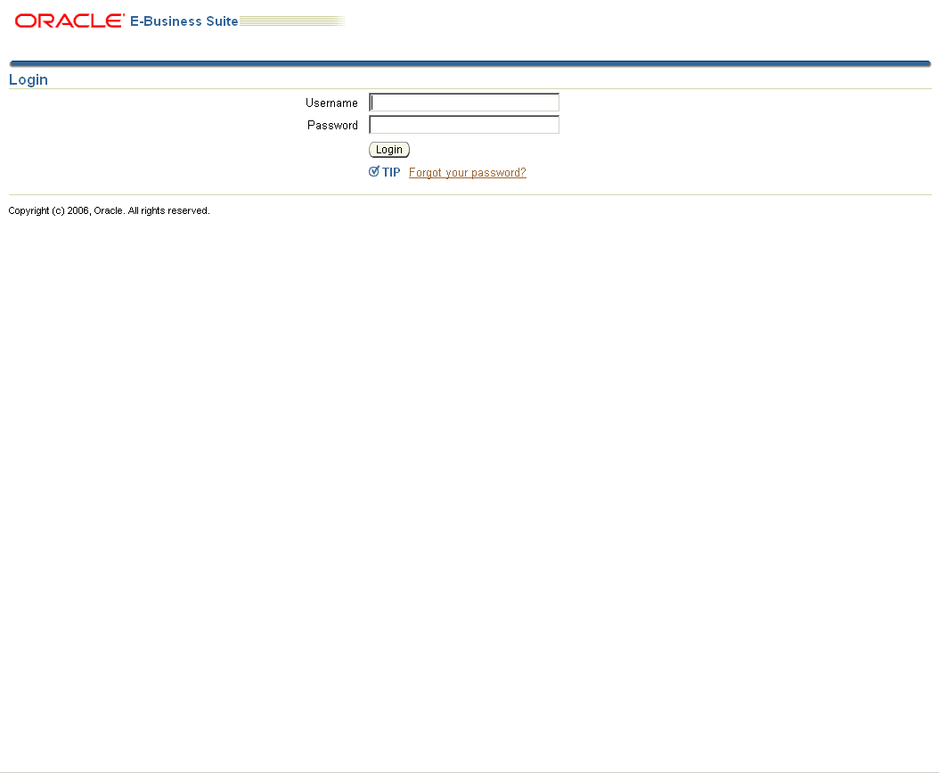
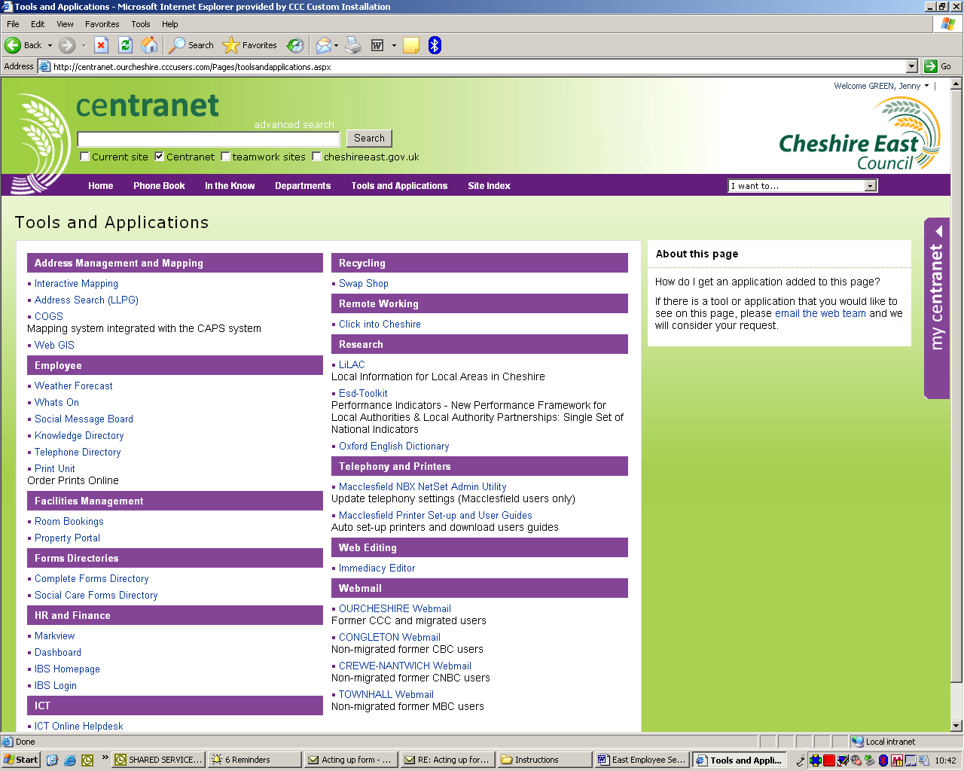

5. Select Employee Self Service

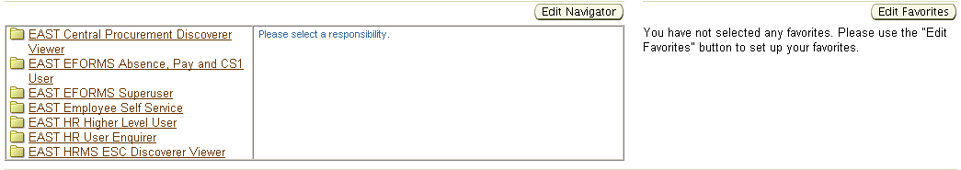

7. Select Personal information, Payslip info, Bank Details
My Information or Emergency Contact

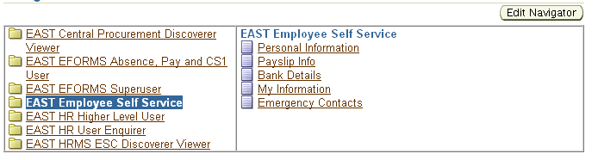
3. PERSONAL INFORMATION

You can view and change the information in your HR record by using Personal Information.

Click Update to the right of the details you wish to change
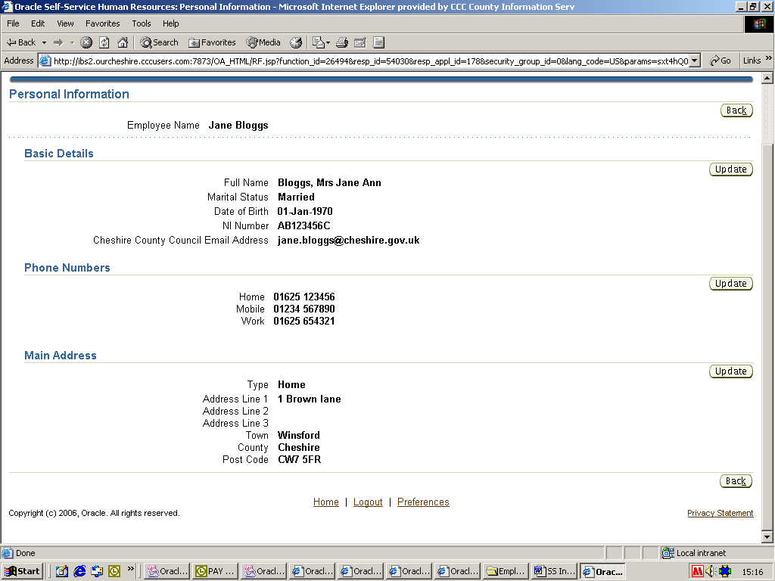

Select the type of change (correction or new details), click Next

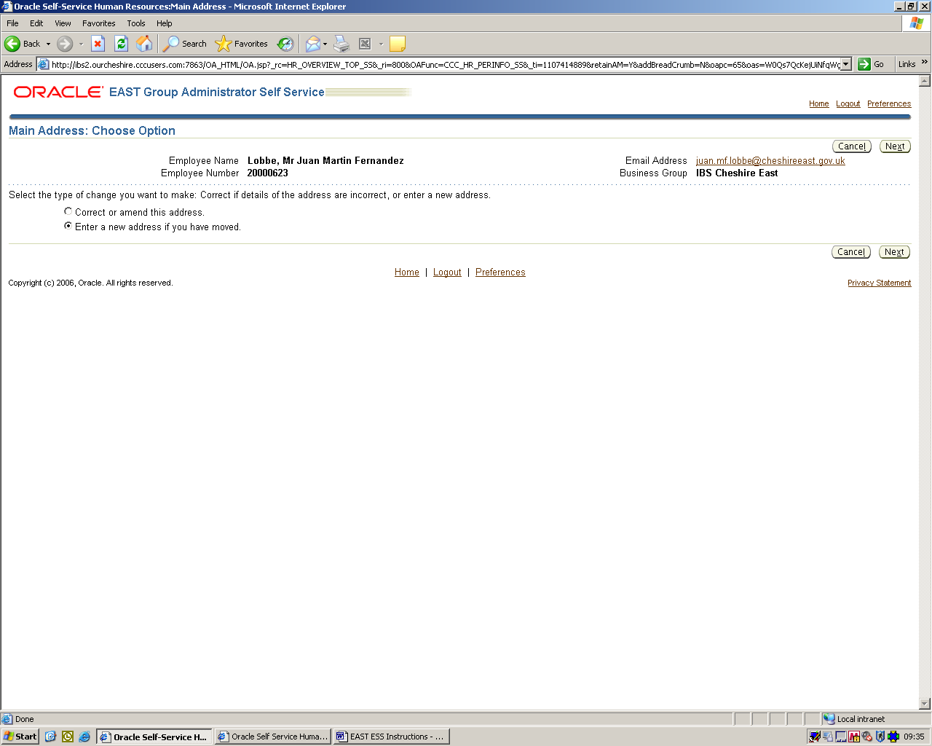

Click Find Address to open the address search window

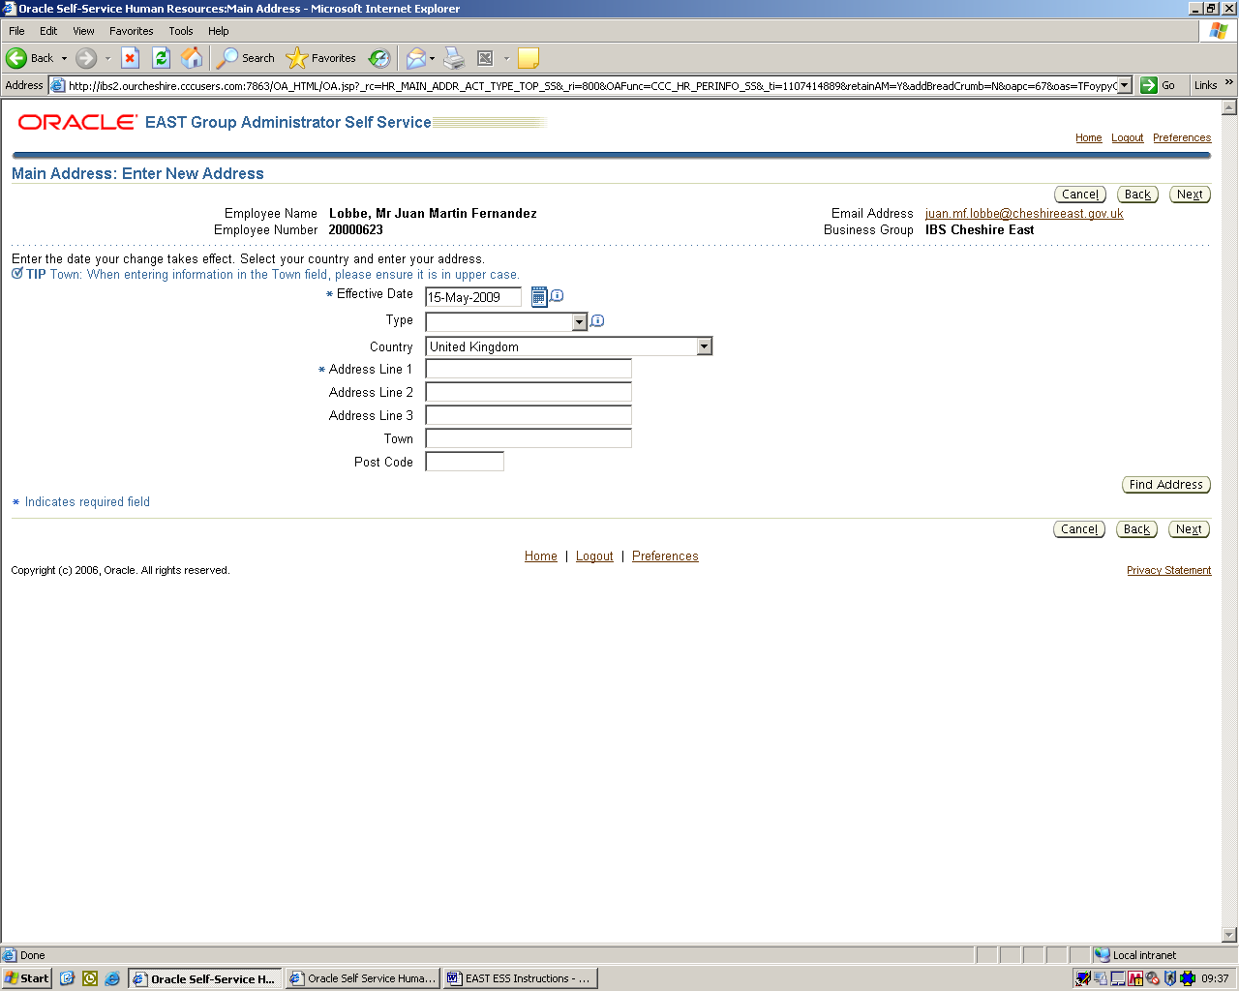

Enter the Building number or name and the Postcode then click Next

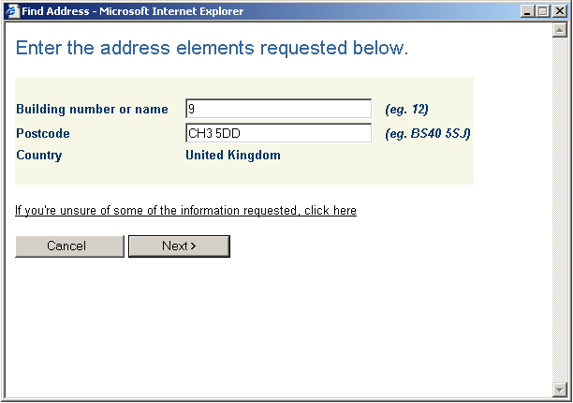

Once you have confirmed the address you have entered is correct click OK

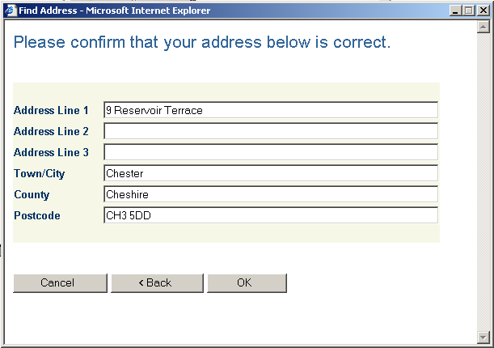

This will update the address information in the changes screen, then click Next

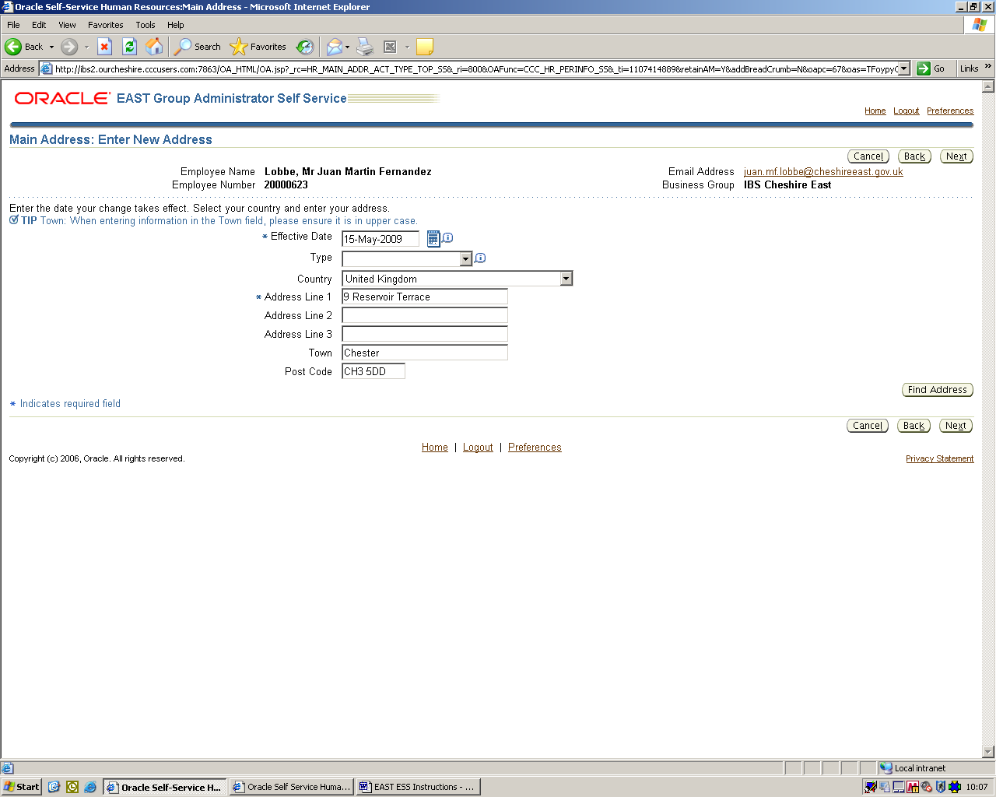
A review screen will appear with a blue dot against the items that were changed.
Check the change, if OK click Submit

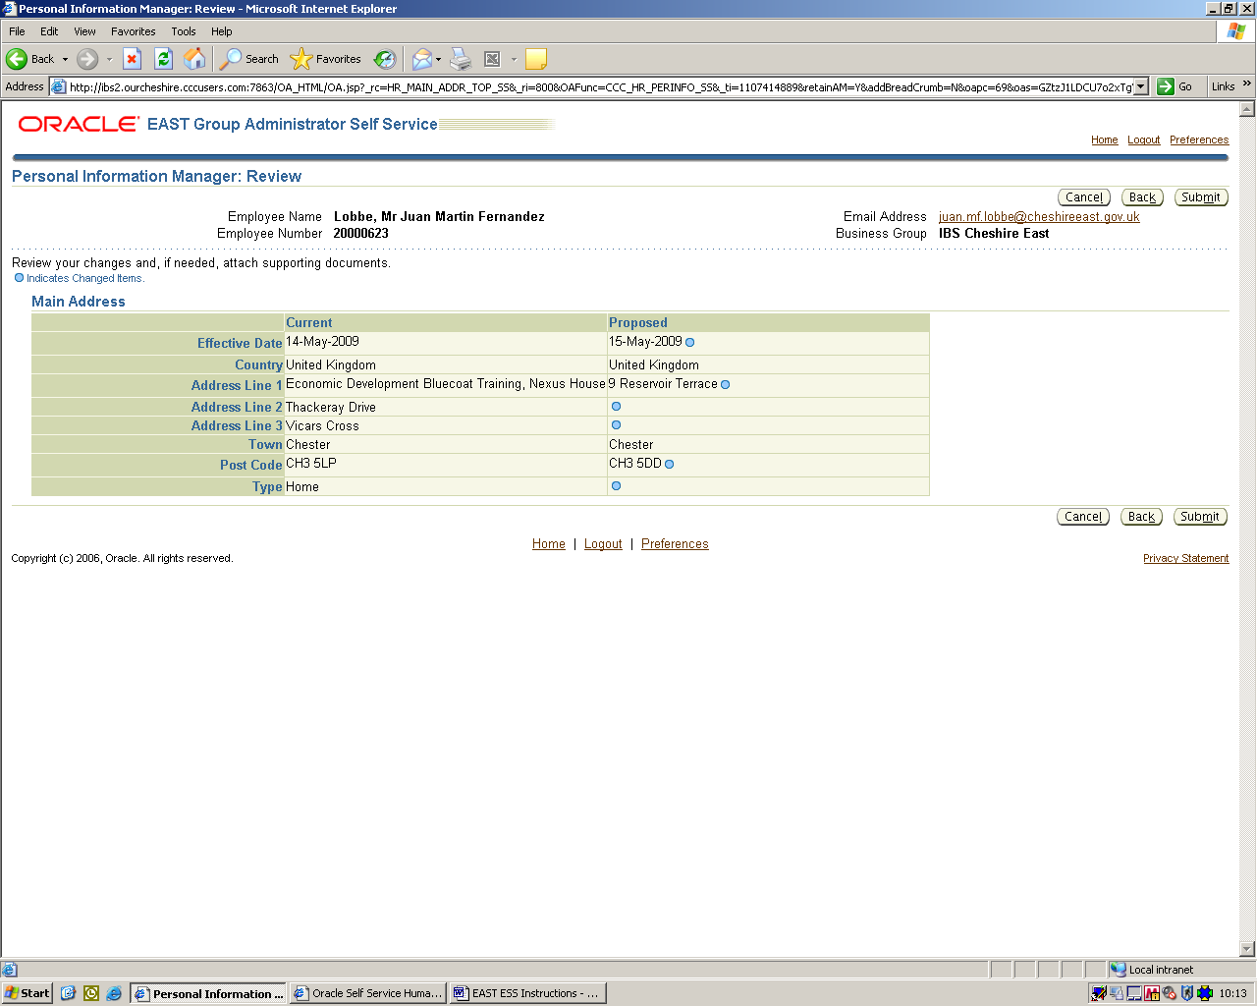

A confirmation screen will appear, click Return to Overview to see your entries, click Home at top of page to return to home page or Logout to log out

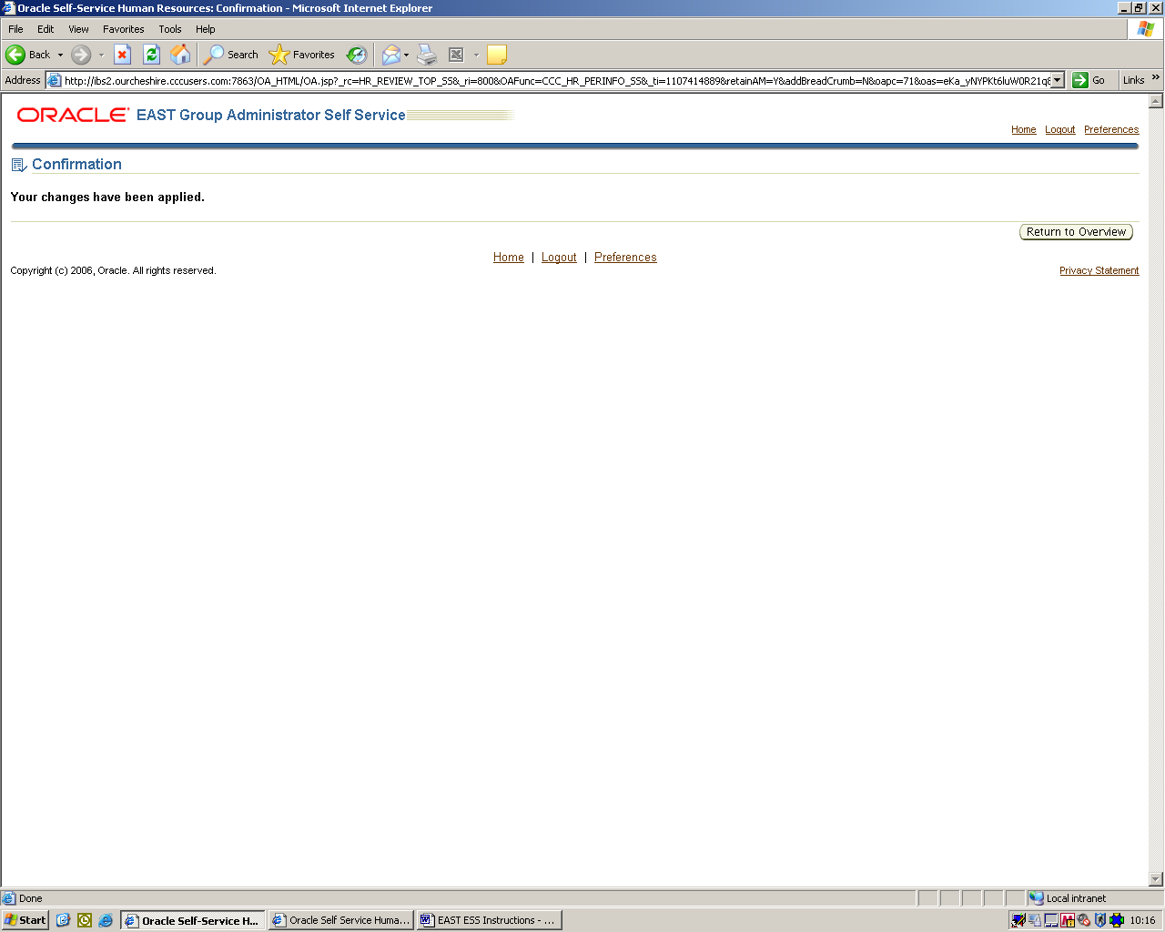

4. PAYSLIP INFO (view only)

You can view your payslips through Employee Self Service by choosing a payslip from the drop down menu, then click Go.

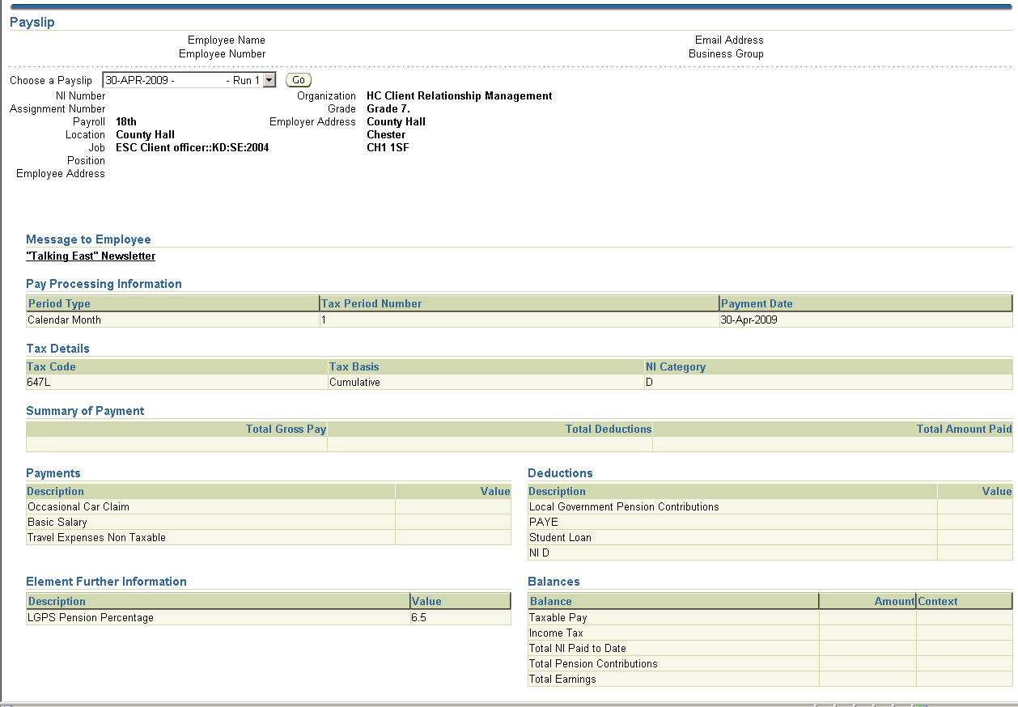

If you require a printed copy of your payslip:
First click view, Text size, Smallest, then File, Print and choose Page 1
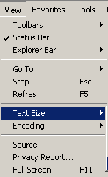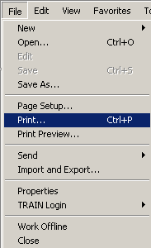

5. BANK DETAILS

Through Bank Details you are able to view or change your Bank Details.

If you have more than one job, select the assignment and click Next
PLEASE NOTE that you must change your bank details on ALL assignments

To change details click Update

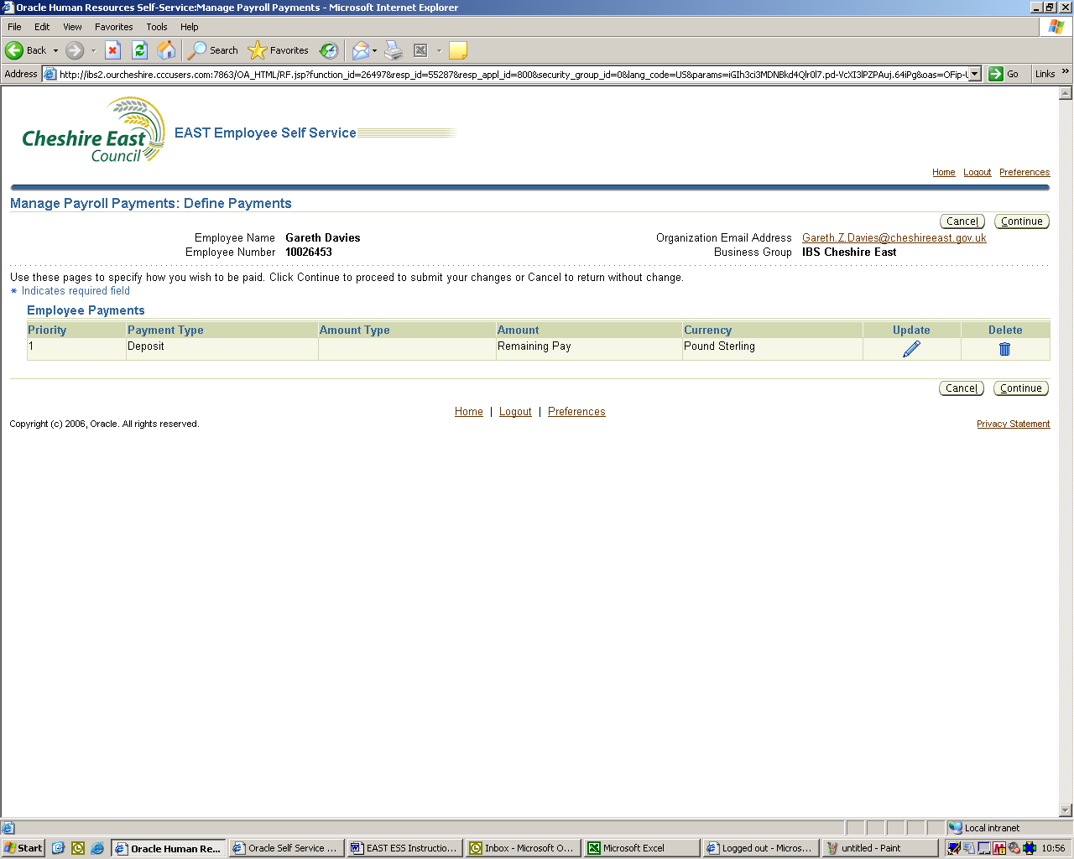

Make any changes as necessary, click Apply

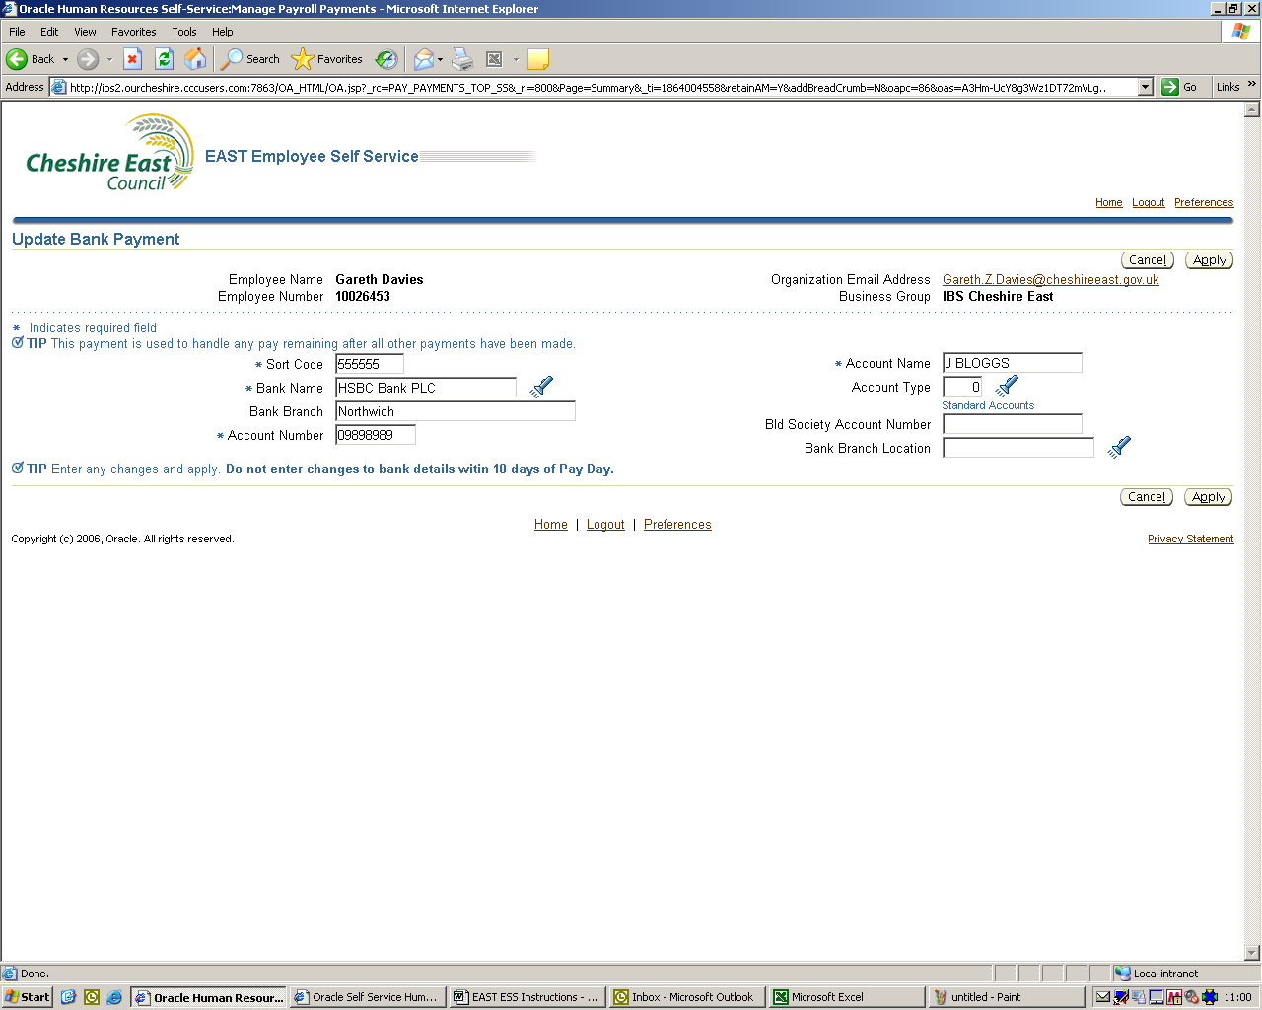

Check the changes, click Submit

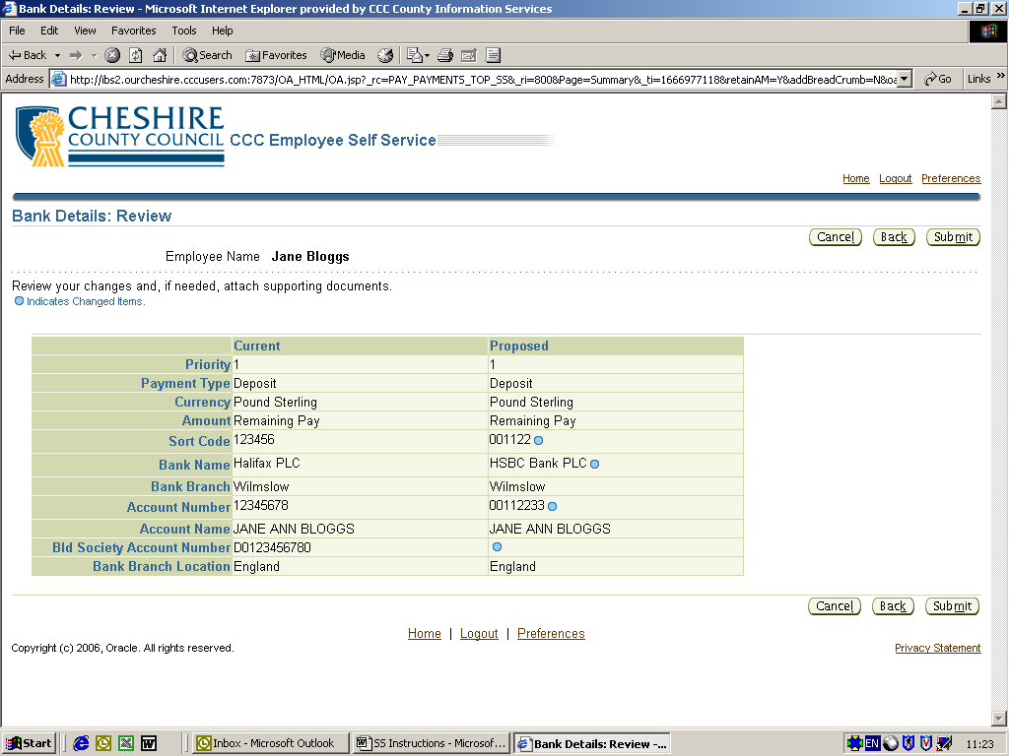

6. MY INFORMATION (view only)

Shows your assignment and absence history by selecting Employment or Absence – for more details, click Show

Employment
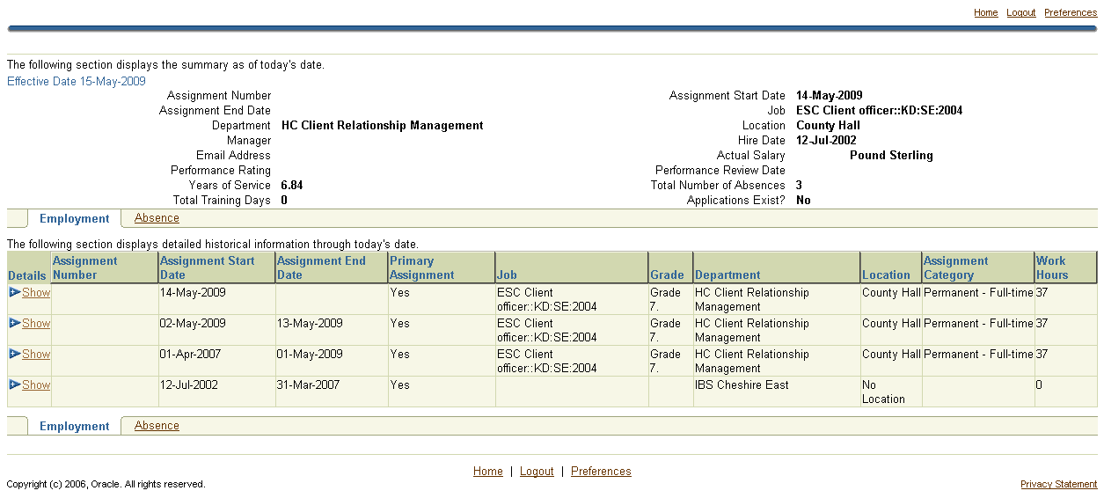

Absence
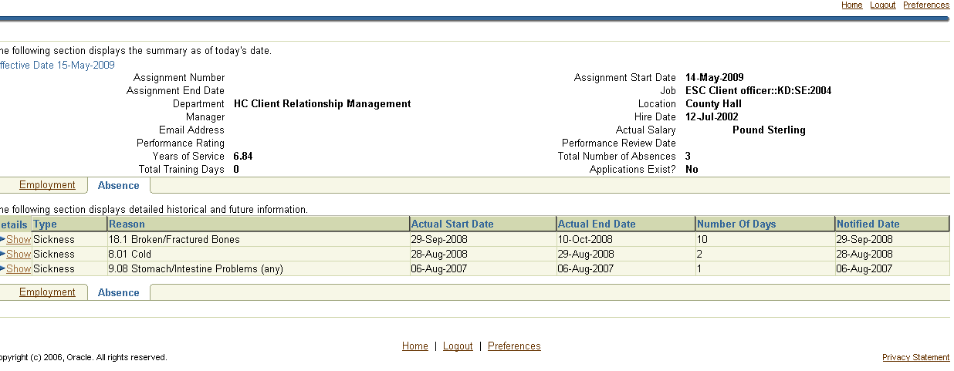

7. EMERGENCY CONTACTS

The Emergency Contacts section is used to add or amend Emergency Contacts to your HR record, these can be accessed by your manager should they be required.

To amend an Emergency Contact click UPDATE, to add a contact click ADD.

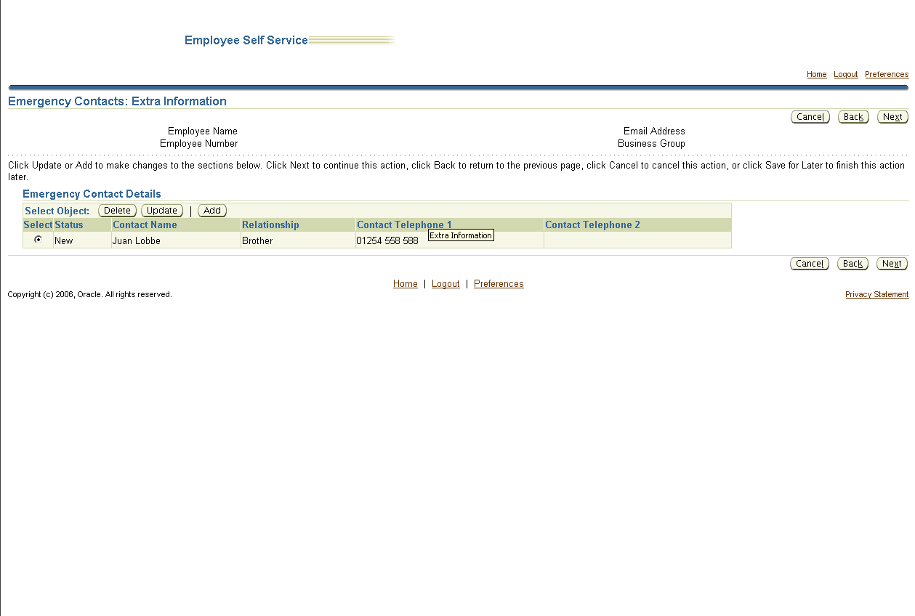

Enter you Emergency Contact details and click on APPLY

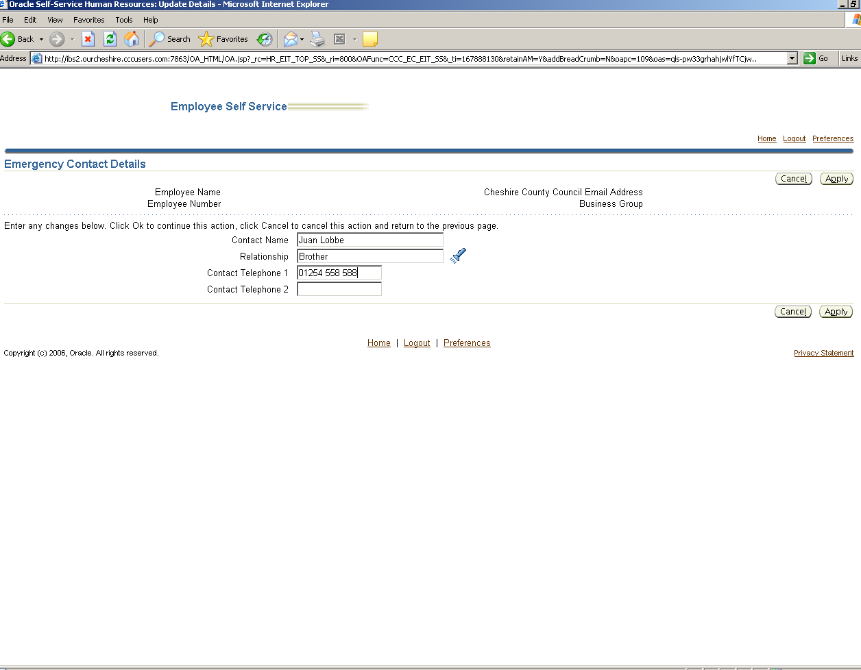

8. LOGGING OUT

Please remember to logout from Employee Self Service by clicking on Logout

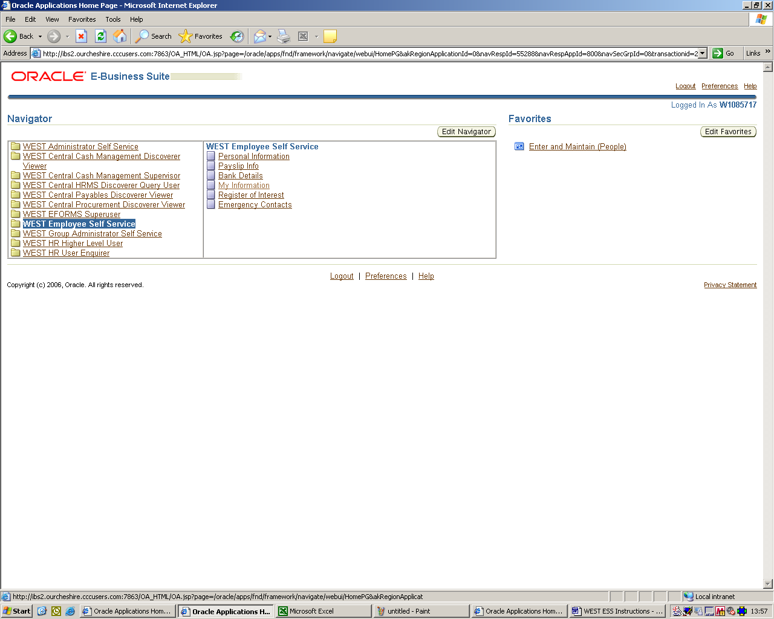

9. WHO TO CONTACT FOR HELP AND ASSISTANCE

For help and assistance contact the Shared Services Client Team

Telephone: 01244 9 72827

E-mail: sharedservices.clientteam@cheshireeast.gov.uk

