

Cheshire East Branch

Benedict’s Law
A Guide for UNISON Members in Schools

September 2026

What is Benedict’s Law?

Benedict’s Law is named after Benedict Blythe, who tragically died after mistakenly being given cow’s milk protein instead of his own oat milk while at school.

Following campaigning by his family and the Benedict Blythe Foundation, the House of Lords approved an amendment to the Children’s Wellbeing and Schools Bill on 3 February 2026. The law establishes mandatory allergy safety measures in schools.

Prior to this, allergy management was largely dependent on local good practice, resulting in inconsistencies between schools somewhat of a post code lottery.

Benedict’s Law represents a significant development in safeguarding children with allergies and creating consistent standards across schools. While the legislation should improve pupil safety, its success depends on proper funding, training, staffing, and consultation.

Key Requirements of Benedict’s Law

Publish a whole-school allergy policy reviewed at least annually

Appoint a named senior leader responsible for allergy safety

Provide allergy and anaphylaxis training to staff likely to be on site with pupils

Hold spare adrenaline auto-injectors for emergencies

Ensure emergency medication is accessible within five minutes anywhere on site.

Maintain Individual Healthcare Plans (IHPs) for pupils with diagnosed allergies.


Record, review and learn from allergy-related incidents and near misses.

The guidance also requires schools to have a dedicated allergy policy, separate from their wider medical conditions policies, and to publish this policy on their website.

UNISON welcomes training that enhances pupil safety and supports measures that improve the health, safety and wellbeing of children and young people. However, the guidance is clear that it must not be used to justify school staff being expected to undertake routine or planned healthcare activities beyond the scope of their agreed role and responsibilities. Appropriate professional boundaries for school staff should be maintained.

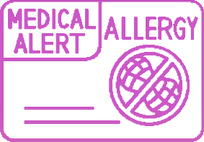
Health & Safety

Approximately two children in every classroom have an allergy.

Schools are among the most common locations for severe allergic reactions.

Up to 30% of severe allergic reactions occur in children with no previous diagnosis.

Given these risks, employers have a responsibility to ensure that:

Risk assessments are updated.

Adequate staffing is available during all school activities.

Emergency medication is maintained and accessible.

Staff are confident and competent through appropriate training.

Incident reporting systems are effective and transparent.

promptly.

Staff Responsibilities Under Benedict’s Law
While Benedict's Law places the overall responsibility for compliance on the school and senior leadership team, all staff who may come into contact with pupils have specific responsibilities in supporting allergy safety. Importantly, allergy awareness responsibilities do not automatically mean responsibility for administering medication or undertaking healthcare procedures.


All staff working when pupils are on site should:

Understand the school's allergy policy.

Attend mandatory allergy awareness and anaphylaxis training.

Be able to recognise the signs and symptoms of allergic reactions and anaphylaxis.

Know how to summon emergency assistance.

Know the location of emergency adrenaline auto-injectors (AAIs).

Follow emergency procedures and reporting requirements.

Report allergy incidents, concerns, and near misses

Be aware of pupils within their classes who have diagnosed allergies.

Teaching Staff and Teaching Assistants should:

Follow Individual Healthcare Plans (IHPs) where appropriate.

Consider allergy risks during lessons, educational visits, celebrations, practical activities, and food-related learning.

Ensure pupils with allergies are included safely in school activities.

Respond quickly if a pupil displays symptoms of an allergic reaction.


Escalate concerns regarding pupil safety to appropriate managers.


Catering staff have particular responsibilities because food is a major trigger of severe allergic reactions. They should:

Catering Staff

- Follow allergen management procedures.

- Ensure food is correctly identified, stored, prepared, and served.

- Prevent cross-contamination where possible.

- Communicate clearly about allergen content.

- Understand emergency procedures if a reaction occurs in dining areas.




- Participate in allergy awareness training and policy implementation.

These staff members should:

Breakfast Club and After School Staff
Know which pupils have diagnosed allergies.

Follow allergy management procedures during food provision.

Ensure emergency medication can be accessed quickly.

Recognise symptoms of allergic reactions.

Follow emergency response arrangements when school leadership may not be immediately present.


Transport Staff

Transport staff are included within the guidance and should:
Be aware of pupils with known severe allergies where relevant.

Understand emergency communication procedures.

Know how to seek urgent assistance if an allergic reaction occurs during transport.

Participate in appropriate allergy awareness training.

Administrative Staff

Administrative staff may be responsible for:
Maintaining medical and allergy records.

Supporting the management of Individual Healthcare Plans.

Recording incidents and near misses.

Assisting communication between parents, school leaders, healthcare professionals, and staff.


Cleaning and Site Staff

Although not directly involved in healthcare provision, they should:
Be aware of allergy control measures.

Follow cleaning procedures that minimise allergen risks.

Report hazards or concerns that may affect pupil safety.

Know how to raise the alarm if a medical emergency occurs.

What protection does Benedict’s Law provide?

Members should note that the guidance specifically states:
1
Allergy
awareness training DOES NOT
automatically make a member of staff responsible for administering
medication.
2
The guidance
SHOULD NOT be
used to require staff to undertake routine or planned healthcare activities outside their role.
3
Staff acting in good faith during an emergency are protected by the guidance's "no blame" approach and should not normally be subject to misconduct action
The guidance specifically promotes a “no blame" culture and states that staff acting in good faith during an emergency, including where there has been hesitation or mistakes, should not be treated as having committed misconduct.

This suggests that where a member of staff:
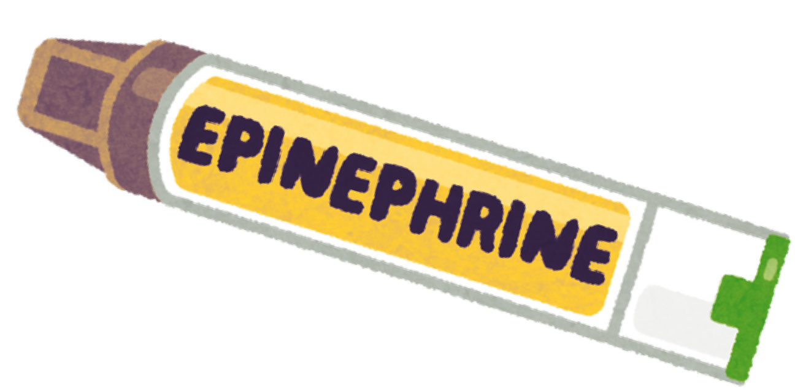
Has received the required training, Follows school procedures,
Acts honestly and reasonably in an emergency,
the intention of the guidance is that they should be supported rather than blamed.

If a trained member of staff uses an adrenaline pen in good faith because they reasonably believe a child is experiencing anaphylaxis, that would generally be viewed as responding to a medical emergency rather than acting negligently.

This is particularly significant for UNISON members, many of whom work in frontline support roles and maybe present during meal times, educational visits, transport arrangements, breakfast clubs, after-school provision, and other settings where allergic reactions could occur.

KEY POINTS FOR MEMBERS:

Benedict's Law does not create a new personal liability on school staff.
The main legal duties fall on the school as an organisation.
Staff should receive training, support and clear procedures.
Staff acting reasonably and in good faith during an emergency should be protected by the guidance's no-blame approach.
Any training to be delivered during working hours.
Employers must provide refresher training and ongoing support.
Regular monitoring of workload and staffing implications

IF THERE IS ANYTHING YOU ARE NOT SURE ABOUT, SPEAK TO YOUR STEWARD OR CONTACT THE BRANCH

01244 346894

mail@cheshireunison.co.uk www.cheshireeastunison.org.uk


Cheshire East Branch


UNISON Office, The Printworks, Sealand Road, Chester, CH1 4RN

