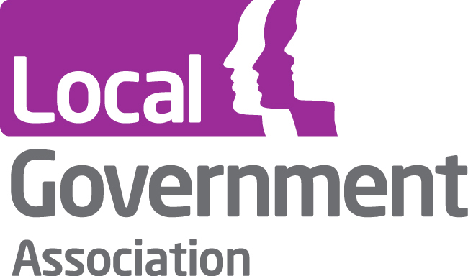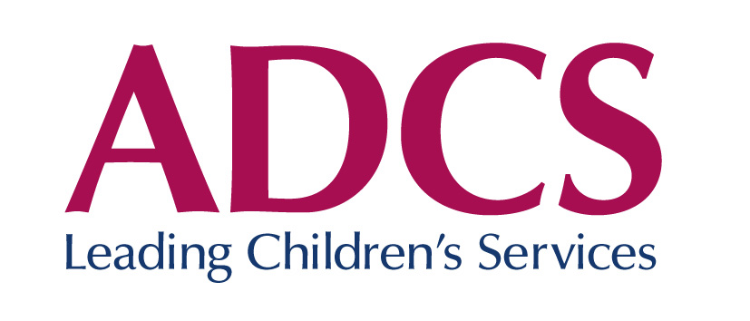

Careers advice and guidance – update on changes to take place during 2011-12

On 4 November 2010, John Hayes, Skills Minister announced that the government would establish an all-age careers service in England http://www.bis.gov.uk/news/speeches/john-hayes-icg-conference . Some elements of the service are planned to be in place from 1 September 2011 and the service is to be fully operational on 1 April 2012. The detail of the service has yet to be developed and this note provides an update on information available at this point.

Legislation

The Education Bill, published on 26 January, changes the duties on schools and local authorities. As far as local authorities are concerned, the general duty to provide services to encourage, enable or assist young people to remain in education and training (section 68 Education and Skills Act 2008) remains but the Secretary of State no longer has the power to direct local authorities to provide particular services or to provide the services to particular individuals (section 69 of the 2008 Act is repealed). The local delivery of the Connexions service providing careers information advice and guidance rests on this power and the guidance provided.

The Bill amends the 1997 Education Act and requires schools to provide independent careers guidance to all pupils - but the requirement to provide a programme of careers education is repealed. Careers guidance must be presented in an impartial manner, must include information on 16-18 education and training, including apprenticeships and must promote the best interests of the pupil who receives it. To be independent, the advice must be provided by someone other than an employee of the school. The provisions of the Bill apply to maintained secondary schools, special schools and pupil referral units. The government intends to apply the same provisions to academies through funding agreements. The Bill allows for the Secretary of State to require, through regulations, that further education colleges also provide careers guidance.

The new all-age service

We expect that the new all-age service will have a recognisable national brand and include on-line, phone and (some) face to face services. Ministers have expressed a wish for the service to have some sort of recognisable local presence and there have been informal discussions with officials about the need to include some locally bespoke content as part of the service alongside the national resource.

Funding

The previous specific funding for the targeted service for vulnerable young people and transitional funding for 2011-12 have been incorporated into the unringfenced Early Intervention Grant. The amounts to be spent on local services are not specified. Clearly local councils will make a range of decisions about transition to the new service depending on other local priorities and budget pressures and it is likely that a range of different local models will develop.

Schools will receive funding for careers guidance through the Dedicated Schools Grant; there will be no specified amount within this grant and schools will be free to discharge their duty to provide impartial, independent careers guidance as they see fit.

Local government’s continuing role

There a number of general themes which colleagues will be aware of, which underpin councils continuing role in advice and guidance for people of all ages.

- Local councils already work in local partnerships with education and training providers to plan education and training for 16-19 year olds, to regenerate economies and tackle worklessness. The first Local Enterprise Partnerships are now underway and will be focusing on how to generate private sector growth and jobs. Careers advice underpins all these efforts and is fundamental to supporting learner choice, aspiration and prosperity for local areas.

- Information about opportunities provided only at national or even regional level will be too broad and too inflexible to be genuinely helpful since a substantial majority of people live within 40 minutes of their place of work. The work that local councils have already done leading the development of area wide prospectuses and common application processes for 16-19 year olds shows how locally relevant, accessible information can be brought together to support the decisions individuals have to make.

- Local councils will continue to be responsible for vulnerable young people who are at risk of not engaging in education or training. They also have a duty to ensure that all young people participate up to the age of 18 by 2015. Many of the young people most at risk will be receiving a range of services from local government and other public and third sector bodies. Councils will be in the lead in terms of delivering the right package of services for these most vulnerable young people including careers and other advice.

- Local authorities retain their duty to provide Learning Difficulty or Disability Assessments (section 139a) for some learners over 16. They will need to ensure that these assessment are carried out appropriately and that they are taking the opportunity to make links between the pre and post 16 assessment frameworks and make it easier for young people and families to make the transition between different stages of education.

Local partnerships

The partnerships that councils develop with local schools and other educational providers through and after transition will be crucial. The shape of the new all-age careers service is not yet clear and it is likely that schools have even less sense of future developments than councils. Local authorities have a vital role to play in communicating the changes to local schools and other providers and in facilitating a discussion about the future role of careers guidance and targeted support and how this will be delivered. Given that it will be for schools and councils to determine for themselves how these are provided, different models are likely to develop, given the current service arrangements and views of the partners. Potentially, local authorities could become providers of careers advice if they wanted to pursue this course.

Issues to be clarified and input from local authorities

The LGA, the Association of Directors of Children’s Services and the national Connexions Network are represented on the national advisory group which has been set up to input to government (Department for Education and Department for Business and Skills) on the development of the service. There will also be a reference group which will look specifically at issues for local authorities. The reference group will be sharing experience from local authorities and seeking to provide useful information to guide local decision-making, rather than attempting to provide central management of the transition. Specific issues to be clarified through these discussions include:

- The degree to which the new service will be operational by September 2011
- Planning for the new service and working with schools. Clarity about the transition and the future shape of the service
- Future data collection on young people and the Client Caseload Information System
- Delivering section 139a assessments for young people with learning difficulties
- Options for developing a targeted service
- Options for careers guidance in schools and working with 14-19 partnerships
- The future role of local authorities – different models eg providing careers guidance, coordinating procurement between schools.
- The role of local information about education, training and jobs within the new service
- Links between children’s and adults’ services and different agencies

February 2011

“Prosperous communities II: vive la dévolution!” LGA February 2007 “Prosperous communities: beyond the white paper” LGA November 2006

